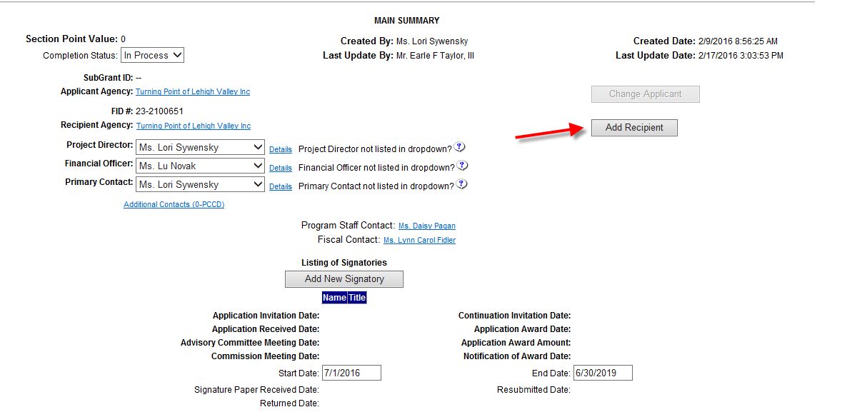
Instruction 1: From the Main Summary Page click on Add Recipient

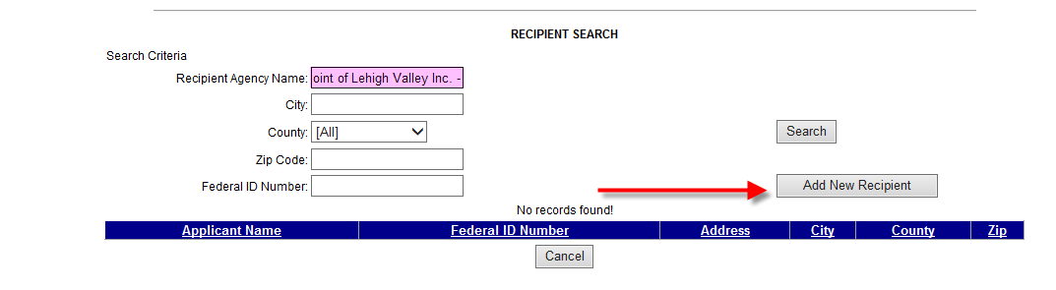

Instruction 2:
- In the Recipient Agency Name type in Turning Point of Lehigh Valley Inc. – Northampton
- Hit search; you will get no results
- Click on Add New Recipient

Instruction 3: The following screen will appear:
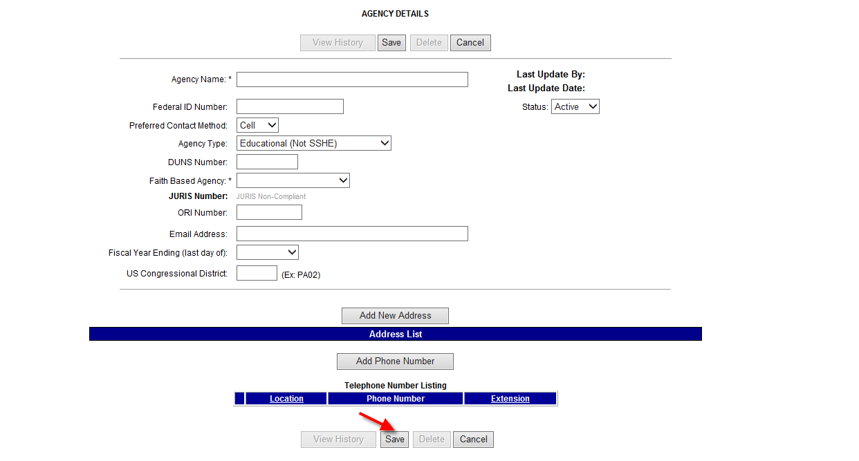
Instruction 4: Complete the information on the Agency Details screen shown above with the Agency Name Turning Point of Lehigh Valley Inc. – Northampton the remainder of the information will be the same information you use for Turning Point Lehigh Valley Inc.

Instruction 5: Hit Save (this will create a new recipient agency so you can prepare a budget for the expenses associated with serving Northampton County. This will take you to the Main Summary Page.

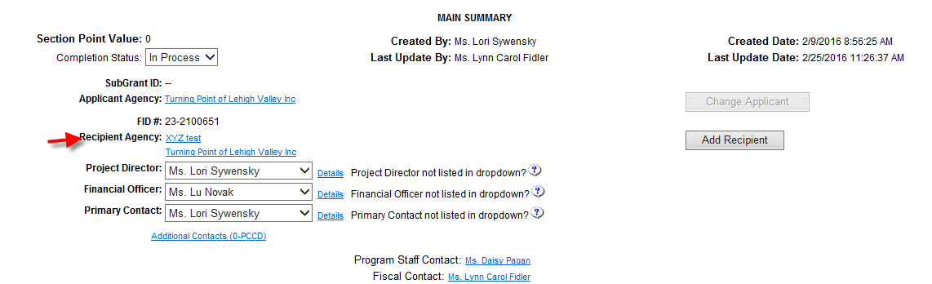
Instruction 6: You will now see the newly established Recipient Agency reflected as shown in the screenshot above. Hit the save button at the bottom of the page

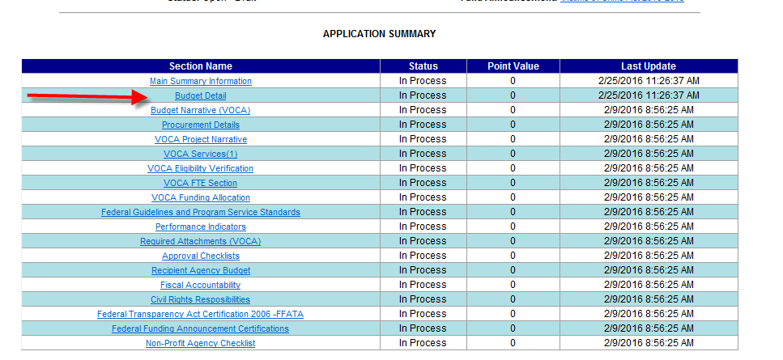
Instruction 7: Click on the Budget Detail line as shown in the screenshot above.

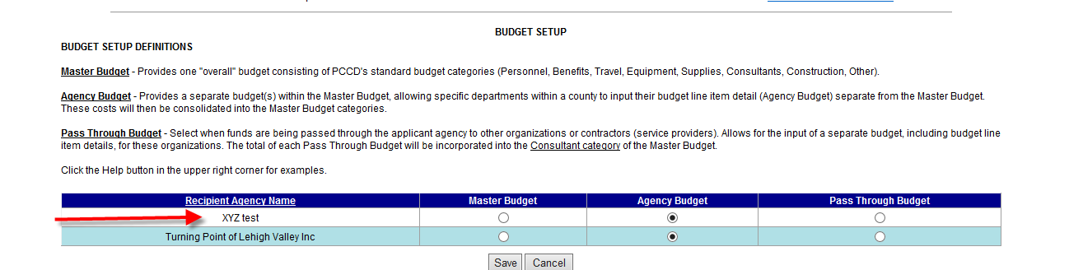

Instruction 8: The Budget Setup screen will appear. Turning Point of Lehigh Valley Inc. – Northampton will appear in the Recipient Agency Name column. Please mark each Recipient Agency as an Agency Budget.

Instruction 9: You will now have a separate Budget for each county you service. Click on the desired county and complete the budget as normal.

