Lt. Governor Austin A. Davis
Chairman
Michael Pennington
Executive Director

OVS Newsletter
April 5, 2023

In this Issue...

- 2023 Crime Victims’ Rights Rally & Summit
- PA Peace Alliance
- RASA/VOJO In-Person Meetings
- Quarterly RASA/VOJO Program Reports Due April 20, 2023!
- 2023 Pathfinder Awards Nominations Now Open!
- Workshop Proposals Currently Being Accepted: 2023 Pathways For Victim Services Conference
- In Harm’s Way How Systems Fail Human Trafficking Survivors
- Department Of Justice Seeks Quick Supreme Court To Action On Guns, Domestic Violence
- Most Gun Violence Against Kids Occurs At Home, Not School
- Supporting Survivors With Community Care
- National Crime Victim Law Institute Rights & Remedies
- How Long Is Long Enough?
- State Program Can Keep Victims’ Home Address From Abusers
- National Child Abuse Prevention Month
- Drawing Connections: Prevention Demands Equity
- Domestic Violence Counts: 17th Annual Report
- Hate Motivated Mass Violence Crimes: Addressing Victtim, Survivor & Community Impact
- Transcend Mobile App

Upcoming Trainings & Events

- Domestic Minor Sex Trafficking: Basic Investigation And Prosecution
- United States v. Rahimi: Implications For Advocates In Supporting Survivors Experiencing Gun Violence
- Working With LGTBQIA+ Victims
- Child Sex Trafficking: From Suspicion To Disclosure
- Context Is Key: Recognizing And Responding To Stalking
- Supporting Survivors In Achieving Permanent, Safe, Accessible, And Affordable Housing
- Sexual Assault Lunch & Learn Series
- Training Series & Peer Support Cohort For Victim Advocates
- Empower – Palooza
- Victims Compensation Assistance Program Online Trainings

Employment Opportunities

- CASA Youth Advocates – Delaware & Chester Counties – Employment Opportunities
- Safe Berks – Employment Opportunities
- Blackburn Center
- Mission Kids Child Advocacy Center Of Montgomery County – Employment Opportunities
- Court Appointed Special Advocates For Children Philadelphia County – Employment Opportunities
- YWCA Hanover Safe Home – Employment Opportunities
- Pennsylvania Coalition Against Rape – Employment Opportunities
- Women’s Center & Shelter Of Greater Pittsburgh
Return to top

2023 Crime Victims’ Rights Rally & Summit
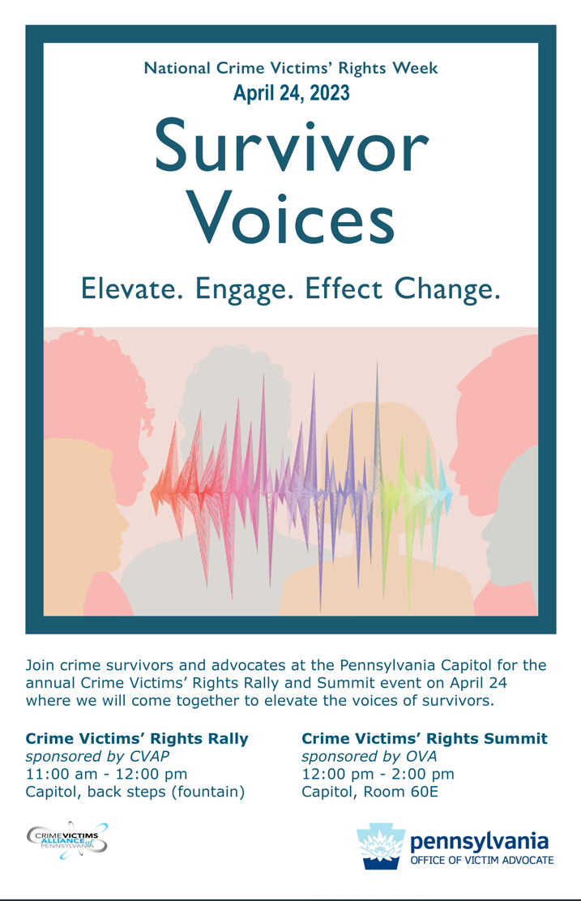
Contact Melany.Nelson@phila.gov to reserve a free exhibit table – a limited number are available.

Return to top

PA Peace Alliance

The “PA Peace Alliance” website and corresponding statewide community of practice is a first-of-its-kind initiative launched as part of PCCD’s Violence Intervention and Prevention (VIP) Grants program. It provides opportunities to connect with and learn from peers and subject matter experts on how to address violence within your community, access live training opportunities and includes a robust digital library with on-demand resources, including gun violence prevention/reduction strategies and related programming, capacity-building for non-profit organizations, fundraising, marketing and outreach tips and other information useful for stakeholders. These resources are provided at no cost to PCCD grantees and other organizations that need them.

Return to top

RASA/VOJO In-Person Meetings

The Office of Victims Services (OVS) is excited to announce it will be hosting three (3) in-person regional meetings to discuss various topics related to RASA/VOJO funding. This will be a great opportunity to identify specific questions or topics you would like to learn more about, meet OVS staff, and network with other RASA/VOJO advocates. The meetings will be at these three (3) locations:
- Dauphin County – PCCD, 3101 North Front Street, Harrisburg, PA 17110 May 12, 2023, 10am – 1pm

- Armstrong County – Belmont Complex, 415 Butler Road, Kittanning, PA 16201 June 9, 2023, 10am – 1pm

- Montgomery County – Women’s Center of Montgomery County, 2506 North Board Street, Suite 203, Colmar, PA 18915-9439 June 23, 2023, 10am – 1pm

In order to register for a meeting, please click on the link below. Registration will be open until Friday, April 21, 2023. If you have any questions regarding the registration, please contact Maria Katulis at mkatulis@pa.gov.

RASA/VOJO In-Person Meeting Registration

Return to top

Quarterly RASA/VOJO Program Reports Due April 20, 2023!

Important Message For All RASA and VOJO Programs - Quarterly Program Reports for the 2023-2024 RASA/VOJO Funding Cycle will cover the time period from January 1, 2023 to March 31, 2023 and should be submitted in Egrants by no later than Thursday, April 20, 2023.

IMPORTANT! ONLY FOR THE FIRST QUARTERLY PROGRAM REPORT OF EACH GRANT YEAR, ALL RASA AND VOJO VICTIMS SERVED ARE CONSIDERED NEW.

REMINDERS:

Please select “No” when asked to make the report a Final Program Report.

You do not need to enter anything in the “Briefly List Activities Conducted During This Period” Section on the main page of the report. You may simply enter “Not Applicable” in this section on the main page of the report and save it.

It is very important to submit your program report in Egrants by the due date of April 20, 2023. PCCD applies a risk level to each sub-grantee. One of the factors that impacts an agency’s risk level is delinquent quarterly reports. RASA and VOJO Reports submitted later than April 20, 2023 may adversely impact the agency’s risk level. If, for any reason, you are unable to enter your report data and submit the report by the due date, please contact our office to let us know so we may instruct you on how to proceed in order to avoid your report being delinquent.

If you should have any questions or need assistance completing your quarterly program reports, please contact Maria Katulis at mkatulis@pa.gov or (717) 265-8741, or Heather Cureau at hcureau@pa.gov or (717) 265-8712.

Quarterly fiscal reports for RASA and VOJO grants will also be due in Egrants by April 20, 2023. If you have any fiscal report questions, please contact the fiscal staff person listed on your grant for assistance.

If you need technical assistance with Egrants, you may contact the Egrants Support Line at (717) 787-5887 or RA-eGrantsSupport@pa.gov.

Return to top

2023 Pathfinder Awards Nominations Now Open!

Nominations for the 2023 Governor's Victim Service Pathfinder Awards is now open! Submitting a nomination is a great way to show respect and appreciation for the efforts made by our very own victim service advocates and allied professionals!

To submit a nomination, please use this link 2023 Governor's Pathfinder Award Nomination Form (office.com) to access the on line nomination form and then email the additional required documents to RA-CD-PATHFINDER@pa.gov. Please review the Pathfinder Criteria & Eligibility document to determine the suitability of your potential nominee and examine the nomination requirements.

Deadline to submit nominations is Friday, April 28, 2023. More information can be found on our website at Governor's Victim Service Pathfinder Awards

2023 Governor's Victim Service Pathfinder Awards will be presented at a special luncheon on Thursday, November 30th at the Pathways For Victims Services Conference.

Pathfinder Award categories include:
- Survivor Activist Award – Those who have survived being a victim and have channeled that experience to make an impact within victim services.
- Outstanding Student Activist Award – Many students volunteer within their community and are dedicated to helping victims. Show them how much we appreciate their activism!
- Allied Professional Award – Look at the other individuals in your community that work as your partner to help crime victims. Examples may include the police officer, district attorney or health care professional that goes above and beyond in the service to victims
- Individual Direct Services Award – To the person who simply believes they are just doing their job, but you know they are doing so much more. A counselor, advocate, victim/witness coordinator, etc. These are the professionals that touch the lives of victims daily and go out of their way to help assist and/or empower those in need.
- Individual Prevention, Education and Outreach Award – The victim service professional that has developed and provided educational programming with enthusiasm for meeting the needs of victims.
- Community Services Award – Given to a nominee that has made a visible contribution and impact upon victim services in their Pennsylvania community.
- Individual Organizational Capacity Building Award – To the individual at an organization that is committed to enhancing the capacity of their agency to better serve victims in their community.

Return to top

Workshop Proposals Currently Being Accepted: 2023 Pathways For Victim Services Conference

Deadline: April 7, 2023
Now soliciting workshop proposals for innovative, practical and inspiring sessions that will provide learning opportunities for victim service providers and allied professionals!

The Pathways For Victims Services Conference will take place November 29th – December 1st, 2023 at The Penn Stater Conference Center in State College.

Ideas for topic areas include, but not limited to:

Homicide Victims | Sexual Assault | Outreach Initiatives | Cross Agency Collaboration
Human Trafficking | Child Abuse | Multi-Cultural/Diversity | Organizational Capacity Building
Mass Violence | Elder Abuse | Underserved Victims | Non-Profit Boards
Victims’ Rights | Domestic Violence | LGBTQIA+ Community | Vicarious Trauma/Self-Care

Click here to access the workshop proposal form. Required information for workshop proposal submission includes:
- Title of the Workshop
- Presenters Name(s) and Agency/Organization Affiliation
- Description of presenter’s experience with the subject matter
- Detailed workshop proposal including learning objectives and presentation style
- Workshop complexity level
- Intended Audience

Each proposal will be reviewed and scored by the conference workshop committee. If you have any questions regarding the conference or workshop proposal process, please email: RA-CD-Pathfinder@pa.gov. For more information about the conference, please visit our website 2023 Pathways Conference.

Return to top

In Harm’s Way How Systems Fail Human Trafficking Survivors

Although the movement to end human trafficking has grown substantially over the last few decades, quality research and empirical evidence remain largely lacking in the field. Existing resources have relied heavily on the Polaris-operated U.S. National Human Trafficking Hotline, which has generated the largest data set on trafficking in North America. However, this data has notable limitations: Not all victims and survivors choose to or are able to contact the Trafficking Hotline; when they do, they are often in crisis situations and share information to connect to services, not for research purposes. Furthermore, such a passive role in data collection skews power dynamics and leaves survivors without control over what story the data tells and how it is used.

The National Survivor Study (NSS) is a scientifically rigorous, multi-phase inquiry that attempts to upend that dynamic and provide an early example of new anti-trafficking research — one in which studies are conducted with survivors, as opposed to about survivors.

Please click here to read.

Return to top

Department Of Justice Seeks Quick Supreme Court To Action On Guns, Domestic Violence

The Justice Department asked the Supreme Court to overturn a lower court decision that struck down a federal law prohibiting gun possession for people under domestic violence restraining orders, Roll Call reports.

Please click here to read.
Return to top

Most Gun Violence Against Kids Occurs At Home, Not School

A recent Pew Research Center survey showed that more than two-thirds of parents worry their children could be shot at school, but that risk to them is far higher in their own homes, The Trace reports. In the five years ending in 2022, three times as many children were shot in domestic violence incidents as in school shootings and eight times as many died, according to an analysis of data from the nonprofit Gun Violence Archive.

Please click here to read.
Return to top

Supporting Survivors With Community Care

Supporting Survivors with Community Care with Dr. Indira Henard is an interview that discusses sensitive treatment of victims of sexual violence.

Please click here to read.
Return to top

National Crime Victim Law Institute Rights & Remedies

NCVLI’s Rights & Remedies shares the latest legal news and analysis of issues surrounding victims’ rights enforcement.

Please click here to read.
Return to top

How Long Is Long Enough?

The Council on Criminal Justice Task Force on Long Sentences was convened to assess drivers of growth in the number of people sentenced to 10 years or more behind bars, the effectiveness of long sentences in preventing and deterring crime, and their effects on incarcerated people and their families, crime victims and survivors, communities, and correctional staff. The panel also examined the impact of such sentences on racial, ethnic, and gender disparities in the prison system, and considered ways to improve the post-release success of people who have served long prison terms.

Please click here to read.

Return to top

State Program Can Keep Victims’ Home Address From Abusers

The Address Confidentiality Program was designed for victims of domestic violence, sexual assault, stalking, human trafficking or childhood parental abductions. The program allows the Pennsylvania Office of Victim Advocate to intercept and forward all first class, signature, and certified mail for those in the program.

Please click here to read.
Return to top

National Child Abuse Prevention Month

National Child Abuse Prevention Month recognizes the importance of families and communities working together to prevent child abuse and neglect. Prevention services and supports developed by this collaboration can help to protect children and strengthen families.

Please click here to read.
Return to top

Drawing Connections: Prevention Demands Equity

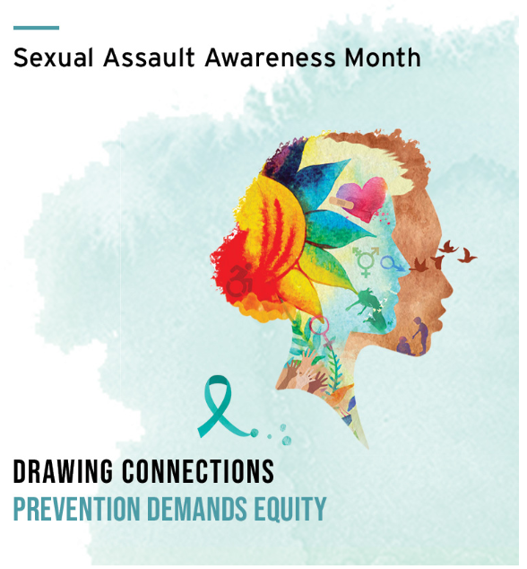

The National Sexual Violence Resource Center has released resources for Sexual Assault Awareness Month 2023. SAAM 2023 has the theme “Drawing Connections: Prevention Demands Equity.”

Please click here to access.
Return to top

Domestic Violence Counts: 17th Annual Report

For the seventeenth consecutive year, on September 7, 2022, the National Network to End Domestic Violence (NNEDV) conducted our Domestic Violence Counts Survey: a one-day, unduplicated count of adults and children seeking domestic violence services in the United States. This annual survey documents the number of people who sought services in a single 24-hour period, as well as the types of services requested, the number of service requests that went unmet due to a lack of resources, and the issues and barriers domestic violence programs face in providing services to victims.

Please click here to read.

Return to top

Hate Motivated Mass Violence Crimes: Addressing Victtim, Survivor & Community Impact

Recently a Fifth Virtual National Town Hall on Mass Violence was hosted by the National Mass Violence Victimization Resource Center and the U.S. Department of Justice Office for Victims of Crime. A video recording of the webinar, a PDF of the presentation slides, and links to all the resources cited during the presentation are available.

Please click here to view.
Return to top

Transcend Mobile App

The National Mass Violence Victimization Resource Center (NMVVRC) has developed the Transcend NMVC mobile app to assist with recovery from the psychological and behavioral response that can occur following direct or indirect exposure to mass violence incidents. Although the app was developed specifically for mass violence victims, people exposed to other types of stressful events are also likely to find the strategies and techniques in the app to be useful in their recovery, as well.

Please click here to read.
Return to top

Domestic Minor Sex Trafficking: Basic Investigation And Prosecution

April 6, 2023 1:00 pm -2:15 pm

This presentation will provide investigators, prosecutors, probation officers, and victim advocates with insight into the culture and dynamics of domestic minor sex trafficking. These cases come with significant hurdles to overcome such as a lack of corroborating evidence or “compliant” victims. The presenter will incorporate case studies and real-life examples of trafficking prosecutions to provide the audience with a basic understanding of trafficking culture, terminology, and the unique circumstances involved in the trafficking of minors for sex.

Please click here to register.
Return to top

United States v. Rahimi: Implications For Advocates In Supporting Survivors Experiencing Gun Violence

Thursday, April 6, 2023 from 1:00 pm - 2:30 pm

This webinar will provide a brief overview of the current federal legal landscape around domestic violence-specific firearms prohibitions in light of the 5th Circuit Court of Appeals’ ruling in United States v. Rahimi. That court found the federal law prohibiting certain respondents to final domestic violence protective orders from possessing firearms unconstitutional, impacting Texas, Louisiana, and Mississippi. Panelists will discuss current federal laws and court rulings, the impact in communities, and ways to work with survivors who are experiencing gun threats.

Please click here to register.

Return to top

Working With LGTBQIA+ Victims
THIS IS AN ENCORE PRESENTATIN OF THE WEBINAR ON APRIL 20. DO NOT REGISTER FOR THIS EVENT IF YOU ARE ALREADY REGISTERED FOR THE WEBINAR ON APRIL 20.

Kelly Burkhardt (she/her/hers)
LGBTQ+ Liaison & Victim Witness Coordinator Philadelphia District Attorney's Office

This training will focus on working specifically with LGBTQIA+ victims including, but not limited to, the recent uptick in violence affecting this community and increasing gender-identity competency while providing crime victim services.
Registration closes on April 12, 2023.

Please click here to register.

Return to top

Child Sex Trafficking: From Suspicion To Disclosure

Wednesday, April 12 from 9:00 am to 4:00 pm

Learn basic techniques and strategies to enhance the likelihood of obtaining information from possible victims of child sex trafficking. Compare and contrast typical child sexual abuse cases with child sex trafficking (CST) cases and address the different points of entry into the criminal justice and welfare system for CST victims. Understand various disciplines' roles and responsibilities and how they can contribute to a positive outcome of the CST case. Examine question strategy, interview dynamics, language use, and interview suggestions. Discuss the business model of child sex trafficking as it relates to a variety of crimes, including the use of child sexual abuse material (CSAM).

Please click here to register.
Return to top

Context Is Key: Recognizing And Responding To Stalking

April 18, 2023 10:00 a.m.

Stalking is criminal, traumatic, dangerous and often misunderstood. This webinar provides an introduction to the crime of stalking, focusing on the definition, prevalence, dynamics, behaviors, and intersections with other victimizations (including intimate partner violence). This recurring webinar is offered quarterly to provide foundational knowledge on the crime of stalking.

Please click here to register.

Return to top

Supporting Survivors In Achieving Permanent, Safe, Accessible, And Affordable Housing

Thursday, April 20, 2023, 02:00PM

We are in one of the worst housing crises since the Great Depression. Across the country, housing inventory is low; development has not kept up with need; interest rates are high; and many rental units are unaffordable. Lavon Morris-Grant, Director of Community Engagement at NRCDV, and Andrea Miller, Housing Director at the Kentucky Coalition Against Domestic Violence, will have a candid conversation on the development of accessible, permanent, affordable, and safe housing for survivors of domestic and sexual violence during this webinar. They will present realistic strategies and outcomes from program implementation across the state of Kentucky.

Please click here to register.
Return to top

Sexual Assault Lunch & Learn Series

Sexual Assault Lunch & Learn Series
These modules are designed to provide information and support for survivors of sexual assault. Survivors are welcome to register for all sessions or for individual sessions. Materials will be provided by mail, and a mailing address is requested at the time of registration.
Questions can be directed to 1-800-563-6399 or RA-OVAinfo@pa.gov.
Please share this information with survivors in our area.
Module 1: Understanding Sexual Assault Trials
April 19 | 12:00 – 1:00 pm
More info and registration here.
Module 2: Empowerment- a pathway to healing
May 11 | 12:00 – 1:00 pm
More info and registration here.

Return to top

Training Series & Peer Support Cohort For Victim Advocates

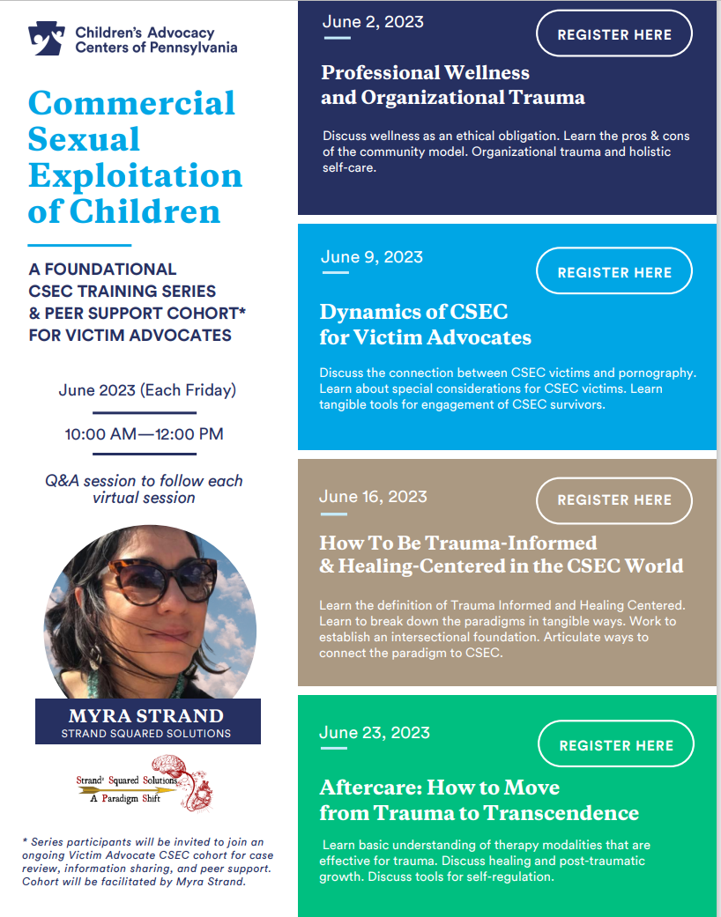

Please click here to register
June 2
June 9
June 16
June 23

Empower – Palooza

A FREE WELLNESS EVENT FOR FAMILIES
April 29, 2023
11:00 am - 3:00 pm
George Washington Carver Center
249 Jacoby St.
Norristown, PA, 19401
FEATURING
Children's Story Time
Healthy Relationship Trivia
Art Workshops
Vendors
Community Groups
& much more

ATTEND
SPONSOR
BE A VENDOR

Attend:
Empower-Palooza!
Apr 29, 11:00 AM – 3:00 PM
George Washington Carver Center, 249 Jacoby St, Norristown, PA 19401, USA
About The Event
Join us for a full day of food, family, fun, and focus on keeping kids safe and empowering them for the future. This event is free but RSVP is requested for planning purposes. Questions?
Contact Kiley Addis, Kiley-Addis@vscmontcopa.org, 610-277-0932 ext. 231.
Vendor and sponsorship information is available on our website.

Return to top

Victims Compensation Assistance Program Online Trainings

The following trainings will be held on April 12, 2023.
- Basic Compensation – 10:00 a.m. – 12:00 p.m.

The following trainings will be held on April 18, 2023.
- Myths of Compensation – 9:30 a.m. – 10:30 a.m.
- Relocation Expenses Clinic –11:00 a.m. – 12:00 p.m.

The following trainings will be held on April 26, 2023.
- “Wow, That’s Covered by Compensation” – 9:30 a.m. – 10:30 a.m.
- Stolen Benefit Cash Expenses Clinic –11:00 a.m. – 12:00 p.m.

The following trainings will be held on May 2, 2023.
- Loss of Earnings Clinic – 9:30 a.m. – 10:30 a.m.
- Counseling Expenses Clinic –11:00 a.m. – 12:00 p.m.

The following trainings will be held on May 10, 2023.
- Loss of Support Clinic – 9:30 a.m. – 10:30 a.m.
- Medical Expenses Clinic –11:00 a.m. – 12:00 p.m.

All trainings count towards 1 hour of the required RASA/VOCA/VOJO training hours, except Basic Compensation which counts towards 2 and DAVE training which counts towards 2.25.

Please click here to register.
Return to top

CASA Youth Advocates – Delaware & Chester Counties – Employment Opportunities

Please click here to see current employment opportunities.

Return to top

Safe Berks – Employment Opportunities

Please click here to see current employment opportunities.

Return to top

Blackburn Center

Please click here to see current employment opportunities.

Return to top

Mission Kids Child Advocacy Center Of Montgomery County – Employment Opportunities

Please click here to see current employment opportunities.

Return to top

Court Appointed Special Advocates For Children Philadelphia County – Employment Opportunities

Please click here to see current employment opportunities.

Return to top

YWCA Hanover Safe Home – Employment Opportunities

Please click here to see current employment opportunities.

Return to top

Pennsylvania Coalition Against Rape – Employment Opportunities

Please click here to see current employment opportunities.

Return to top

Women’s Center & Shelter Of Greater Pittsburgh

Please click here to see current employment opportunities.

Return to top

The next OVS Newsletter will be published on Wednesday, April 19, 2023. If you would like any training events, fundraisers, or notable news published in this newsletter, please submit them to Lea Dorsey at ledorsey@pa.gov by Wednesday, April 12, 2023.

You have signed up to receive the OVS Newsletter from the Office of Victims' Services. This newsletter will be sent to you on a biweekly basis via email. If your email address changes or you would like to be removed from the OVS Newsletter distribution list, please contact Lea Dorsey at (717) 265-8733 or via email at ledorsey@pa.gov.
Return to top
Pennsylvania’s Office of Victims’ Services | 3101 North Front Street | Harrisburg, PA 17110 |
(717) 783-0551
www.pccd.pa.gov
PA Crime Victims Website
www.pcv.pccd.pa.gov
Twitter: @PaCrimeComm.

