Charles Ramsey
Chairman
Michael Pennington
Executive Director

OVS Newsletter
October 20, 2021

In this Issue...
- Compensation Corner
- Gun Violence Is Claiming More Young Victims
- Bureau Of Justice Statistics Report On Service For Crime Victims
- #PurpleThursday
- 2022 National Crime Victims’ Rights Week
- Services For Crime Victims, 2019
- Deputy Attorney General Testimony
- Homicide Trends: What You Need To Know
- Parallel Justice
- Hate Crime Recorded By Law Enforcement, 2010-2019
- Media Guide For Reporters, Editors, And Media Professionals
- Back To Basics: Partnering With Survivors And Communities To Promote Health Equity

Upcoming Trainings & Events

- Cultural Responsivity In Domestic Violence Intervention Approaches For Immigrants In The U.S.
- Survivors Support Group For Sexual Assault
- Group Crisis Intervention Training
- Which One Will You Choose
- End Abuse Of People With Disabilities
- Training Institute On Strangulation Prevention
- Third Thursday Series
- Victims Compensation Assistance Program Online Trainings

Employment Opportunities
- Central Division Victim Services – Employment Opportunities
- PAAR – Employment Opportunities
- Neighborhood Legal Services – Employment Opportunities
- YWCA Greater Harrisburg – Employment Opportunities
- Network of Victim Assistance – Employment Opportunities
- Blackburn Center – Employment Opportunities

Upcoming Events
  - WebEx Online Trainings Available
Compensation Related: Basic Compensation and much more!
Credits towards VOCA/RASA/VOJO training requirements are available for all sessions (unless indicated otherwise in the session description). To receive training credits: 1) you must be logged into the session and 2) the WebEx application must be on your computer for the entire duration of the session. As the OVS recognizes that emergencies may arise and you may not be able to attend the entire session, there is no prohibition against attending part of a session (although training credits will not be given in that instance).

Return to top

Compensation Corner

VCAP has recently revised the DAVE Access brochure, Financial Assistance Brochure and Compensation Resource Guide. The DAVE Access brochure and the Financial Assistance brochure have also been translated into Chinese, Spanish, German, Korean, Vietnamese, and Russian.

The DAVE Access brochure is a good resource for victims/claimants to have. The document explains to them how they can access their claim information by utilizing the DAVE system, the PA Crime Victims app, contacting their local victim service program or calling the VCAP. This two page document provides valuable information for the victim/claimant on how to use DAVE.

The Compensation Resource Guide is a document for Victim Services and allied Professionals. This two page document provides a brief overview of the Available Benefits with VCAP.

The Financial Resource document is a one page document for victims/claimants to utilize. This one page document provides a brief overview of VCAP including eligibility, expenses that can be covered, and additional information.

We have also added a QR code to all three of these revised documents that will take you directly to the PA Crime Victims website where additional information is available.

All of these documents can be found on the PCCD website at Forms and Apps (pa.gov)

Return to top

Gun Violence Is Claiming More Young Victims

The FBI says that homicides among victims 19 years old or younger rose more than 21% in 2020 and this year figures to be even worse. Experts say that a spike in gun sales during the pandemic, along with widespread shutdowns, help explain the tragic rise. Social media also plays a role in fueling violent rivalries. Police officials and violence interrupters around the country are struggling to react to cycles of violence and retaliation. So are parents. “I don’t think people know how hard it is, not to want to retaliate,” says one grieving father.

Please click here to read more.
Return to top

Bureau Of Justice Statistics Report On Service For Crime Victims

This report presents statistics on five types of victim service providers (VSPs) that assisted crime victims in 2019: nonprofit or faith-based; governmental; hospital, medical, or emergency; campus; and tribal VSPs. The report examines the average number of services provided, types of commonly provided services, gaps in service, and organizations that typically referred victims to VSPs for assistance.
Findings are based on data from the National Survey of Victim Service Providers, which BJS conducted for the first time from May to November 2019.
Please click here to read the full report.
Return to top

#PurpleThursday

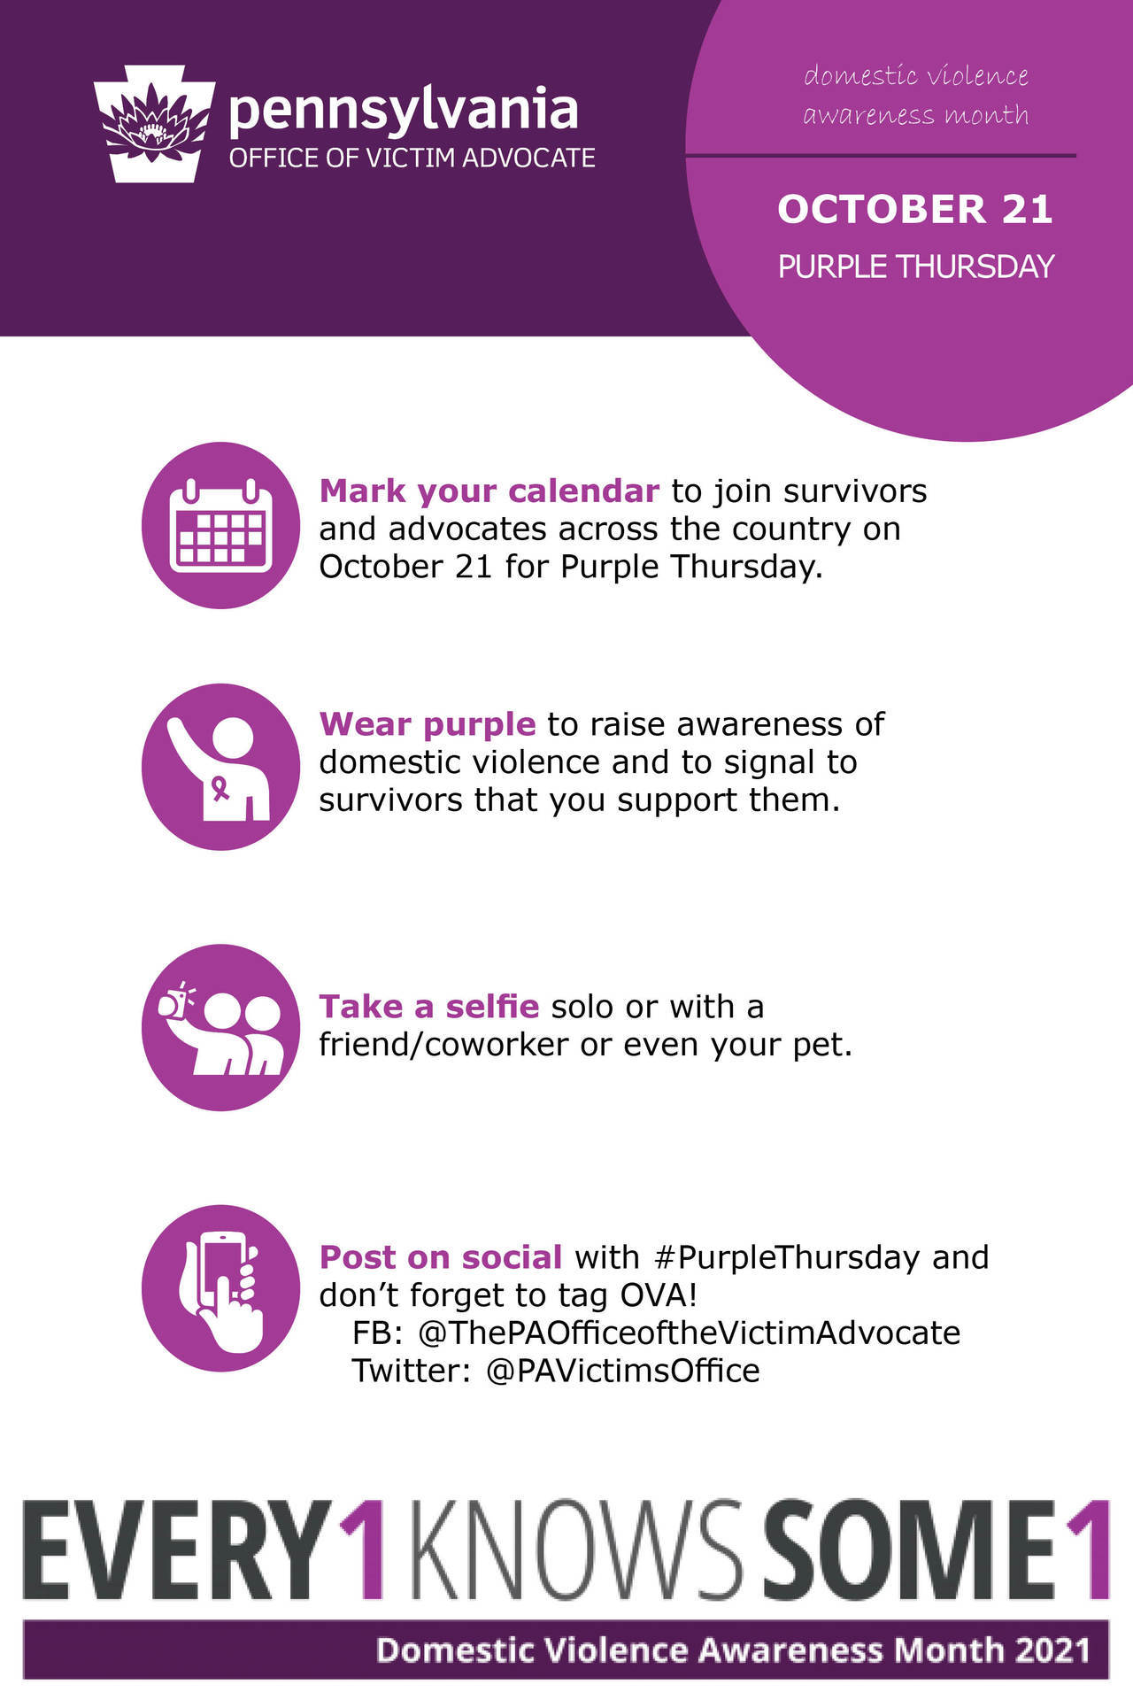

October is Domestic Violence Awareness Month and one of the easiest ways to raise awareness and show support for survivors is by participating in Purple Thursday. On October 21, OVA invites you to join us in wearing purple!
Snap a selfie and post with #PurpleThursday. Don't forget to tag OVA...
Facebook: @ThePAOfficeoftheVictimAdvocate
Twitter: @PAVictimsOffice

Return to top

2022 National Crime Victims’ Rights Week

The Office of Victims of Crime has announced its theme for 2022 National Crime Victims’’ Rights Week, scheduled for April 24-22: Rights, access, equity for all victims.

Please click here to read more.
Return to top

Services For Crime Victims, 2019

This statistical brief provides an overview of the scope and status of victim/survivor services nationwide.

Please click here to read.
Return to top

Deputy Attorney General Testimony

USDOJ Deputy Attorney General Lisa Monaco’s testified before the Senate Judiciary Committee about reauthorizing VAWA.

Please click here to read.
Return to top

Homicide Trends: What You Need To Know

Each fall, the Federal Bureau of Investigation aggregates and distributes annual crime data from law enforcement agencies across the country. Many agencies now post their own weekly and monthly data online, permitting researchers, including those at the Council on Criminal Justice (CCJ), to analyze and report trends in closer to real time. On September 27, the FBI released its year-end report for 2020. The government’s figures largely mirrored what CCJ and Arnold Ventures reported in January based on a sample of 34 cities. Both reports, for instance, indicated that in 2020 homicide increased by nearly 30% over the year before. This brief summarizes key takeaways based on the newly issued FBI report as well as historical and more recent data.

Please click here to read more.
Return to top

Parallel Justice

Coming from the National Center for Victims of Crime, Parallel Justice is a trauma informed and survivor centered podcast that investigates civil justice sought for criminal acts. Dive into the realities of our criminal justice system alongside expert attorneys who took on the cases that dominated the headlines and changed our society. This is not your typical True Crime show. Parallel Justice is an honest, empowering investigation into how the Justice system actually works, where it fails, and how survivors can seek accountability. The National Center for Victims of Crime advocates for victims’ rights, trains professionals who work with victims and survivors of crime and serves as a trusted source of information on victims' issues.

Please click here to read more.
Return to top

Hate Crime Recorded By Law Enforcement, 2010-2019

The Bureau of Justice Statistics recently published “Hate Crime Recorded by Law Enforcement, 2010 – 2019. “This report presents data from the FBI’s Uniform Crime Reporting Hate Crime Statistics Program (HCSP) on hate crime incidents and victims from 2010 to 2019. The HCSP, which began in 1990, collects hate crime data regarding criminal offenses motivated, in whole or in part, by the offender’s bias against a race or ethnicity, religion, disability, sexual orientation, gender, or gender identity. The HCSP includes crimes reported to police that, after investigation, reveal sufficient evidence to support being recorded as hate crimes. The report examines incidents and victims of hate crime recorded by law enforcement, trends over time in total hate crimes, and hate crimes motivated by bias against the victim’s race, ethnicity, or ancestry.”

Please click here to read.
Return to top

Media Guide For Reporters, Editors, And Media Professionals

NNEDV has just published a Media Guide for Reporters, Editors, and Media Professionals that has resources about covering violence against women, with tips from survivors themselves.

Please click here to access.
Return to top

Back To Basics: Partnering With Survivors And Communities To Promote Health Equity

This paper makes connections between health equity and our work to prevent sexual and intimate partner violence. It centers the stories of survivors at the intersections of systemic racism, violence, and oppression. It explores ways to build both individual and organizational capacity to address health inequity. And, it offers a call to action for those ready to commit to health equity in their gender-based violence prevention work. This document was co-authored by staff of the National Sexual Violence Resource Center and National Resource Center on Domestic Violence, with significant input, guidance, and leadership from Black and women of color survivors and advocates.
Please click here to read more.
Return to top

Cultural Responsivity In Domestic Violence Intervention Approaches For Immigrants In The U.S.

While all communities can experience domestic violence, immigrants are at a higher risk of victimization due to their unique positionality in the United States. In this webinar, presenters will highlight findings of their scoping review about culturally responsive interventions for immigrants in the U.S.

October 27th 2:00 – 3:00 pm

Please click here to register.
Return to top

Survivors Support Group For Sexual Assault

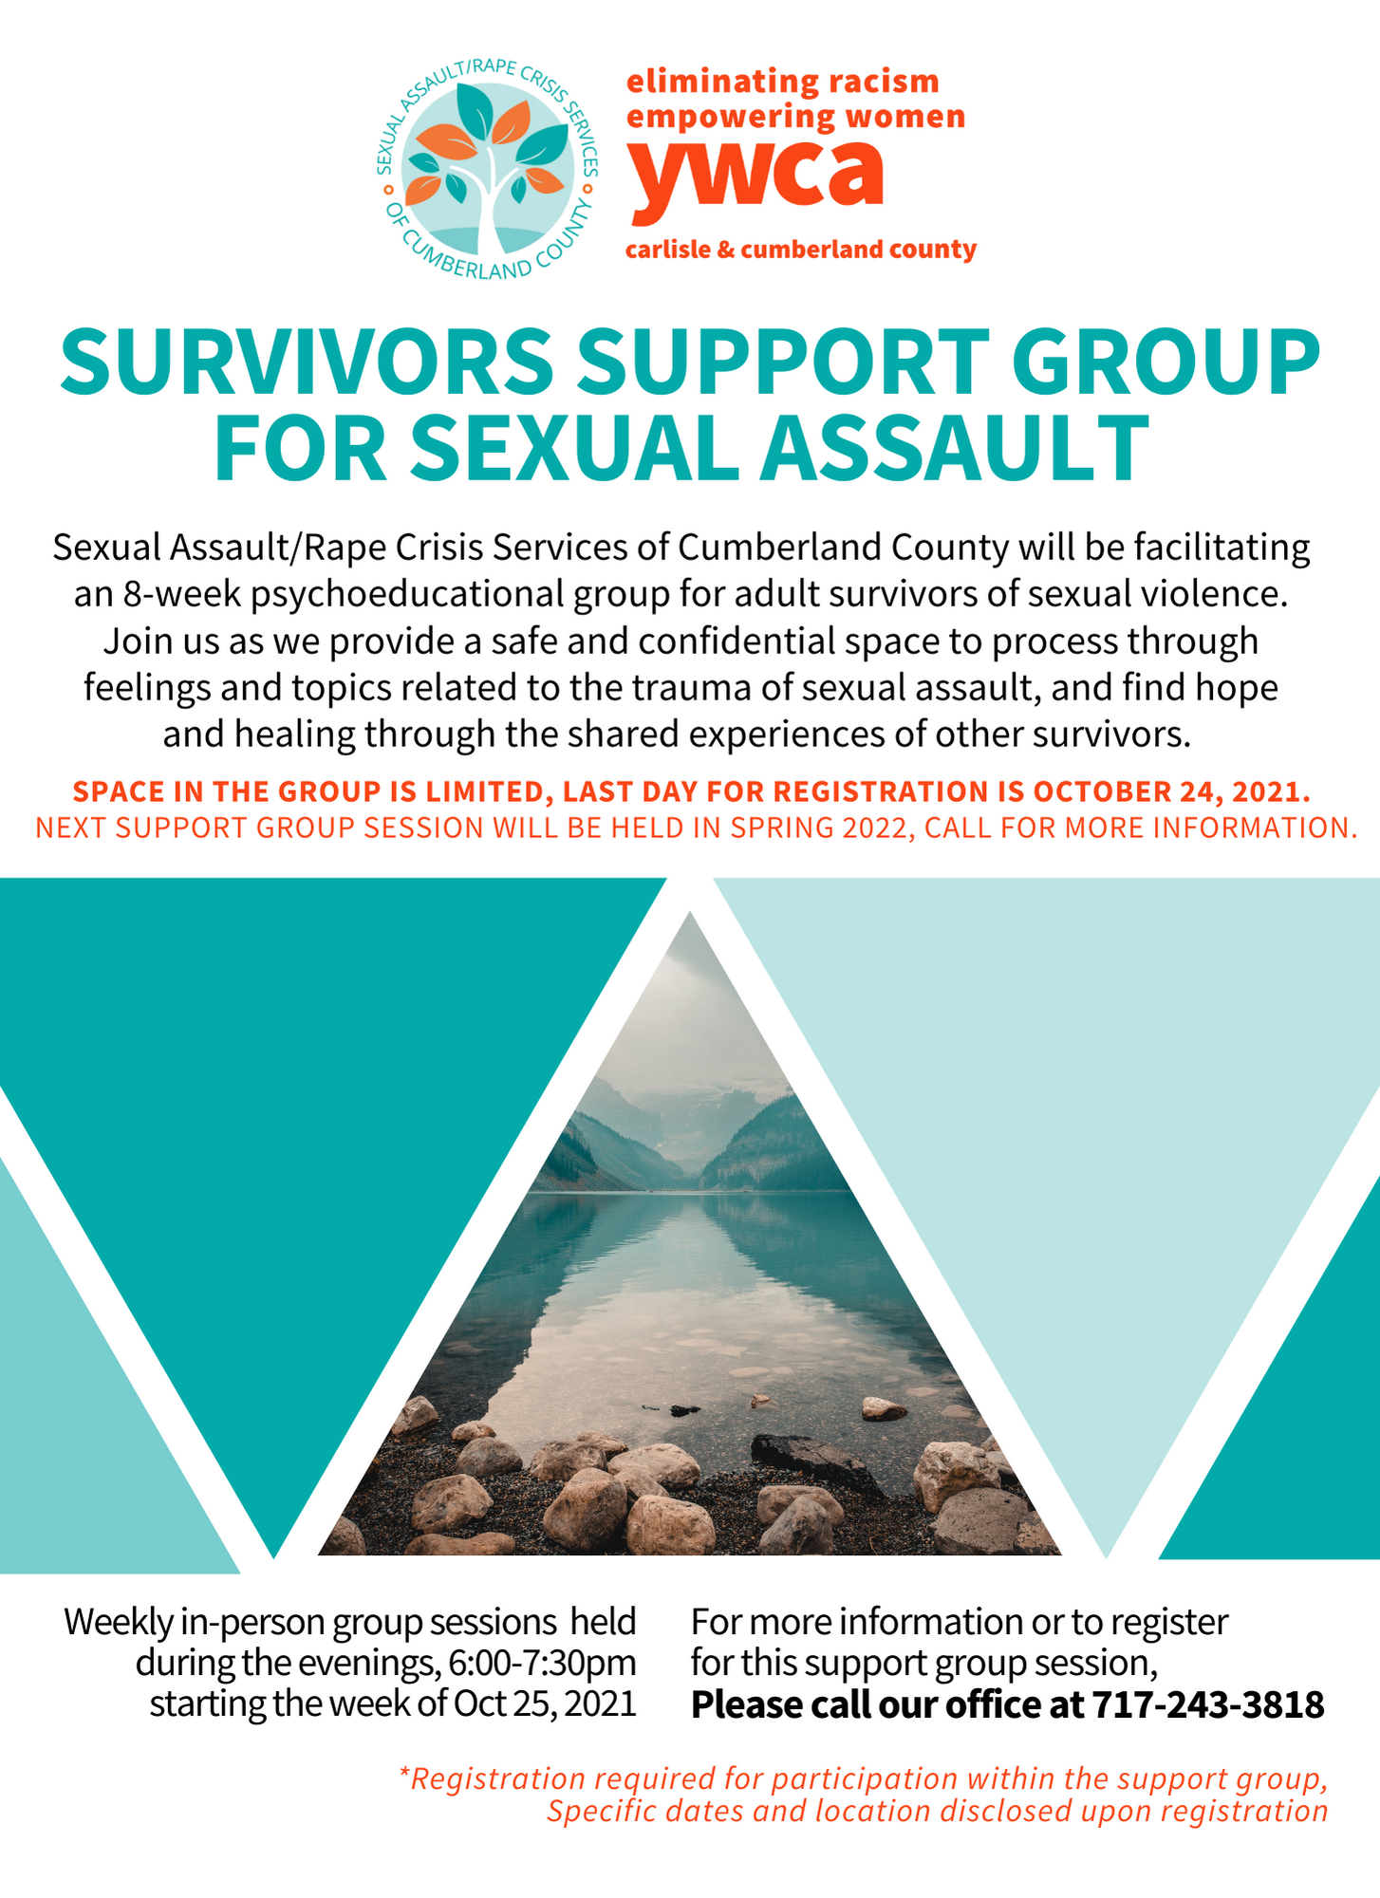

Return to top

Group Crisis Intervention Training

Learn the Group Crisis Intervention Model to respond to community trauma.

Become KCIT Certified—Join a Statewide Team

KCIT’s Group Crisis Intervention (GCI) is a secondary response that addresses the gap that exists in-between traditional trauma services offered. After a tragic event, first responders leave and a community may then be left on its own to navigate their path forward. KCIT can address large numbers of people at a time to help a community come together and to start to tell the story of what happened and connect them to necessary resources and services.

During a GCI a group is led by a facilitator through a series of questions using time progression—starting in the past, present, and then future. Questions aim to help participants sort through their experience of the event, sensory impact, reactions, and what they continue to hold as a result of the trauma. The group process assists in restoring connection and the feeling that “I am not alone” in my suffering. It is important to understand that a GCI is not therapy and is a onetime intervention.

Length: 12 hours
Cost: Provided at no cost!!! Funding made possible by PCCD
Format: Offered in four 3 hour sessions
Dates: Four Tuesdays in November
- November 9, 2021
- November 16, 2021
- November 23, 2021
- November 30, 2021
Time: 1:00-4:00 PM
(Must attend all sessions to receive KCIT Certification)
Registration: Register by 10/29/2021

Please click here to register.

Return to top

Which One Will You Choose

NCVLI's annual Crime Victim Law Conference
is really TWO Conferences – virtual and in-person.
The Virtual Conference will be held over five Fridays –
October 15, 22, 29 & November 5, 12.
The In-Person Conference will be held November 11 – 13 in Portland, Oregon.

In-Person Conference attendees can add a Virtual Conference ticket when they register for an additional $80.  Register Now | Register now to save. Early bird rate is now available until October 14th.  Early Bird Registration

Return to top

End Abuse Of People With Disabilities

New webinar series!
Focusing on gaps in addressing abuse,
vulnerable groups, racial justice and disability

FISA Foundation and Southwest PA Says No More are partnering with The Vera Institute of Justice's End Abuse of People with Disabilities initiative on a three-session interactive webinar series to bring together experts at the intersections of disability, domestic and sexual violence, campus violence, human trafficking, and racial justice.

See below for the complete list of co-sponsors.

Session 3 - Transformative Justice in the Lives of Survivors with Disabilities
Date will be announced soon, early-mid November

With high rates of victimization and incarceration, people with disabilities have an elevated likelihood of having contact with the criminal legal system. This contact can be deadly, with 50% of people killed by police in the United States having a disability. This long history of being harmed by the state-sponsored justice system has led people with disabilities, and specifically people of color with disabilities, to seek alternative ways to heal and promote accountability. Transformative Justice (TJ) was created by and for people from marginalized communities to respond to violence when calling the police may not be a viable or safe option.

Co-Sponsors

• Autism Connection of Pennsylvania  • Black Girls Equity Alliance  • City of Pittsburgh Gender Equity Commission  • Gwen's Girls  • Institute on Disabilities at Temple University  • New Voices for Reproductive Justice  • Opportunity Fund | • Pittsburgh Center for Autistic Advocacy  • Pittsburgh Council on Higher Education (PCHE)  • Self Advocates United as 1  • SisTers PGH  • University of Pittsburgh School of Education  • UPMC Children's Hospital of Pittsburgh, Division of Adolescent and Young Adult Medicine

Southwest PA Says No More | Website | ‌

Return to top

Training Institute On Strangulation Prevention
One-day Virtual Strangulation Training: “The Last Warning Shot”

Presented by The Training Institute on Strangulation Prevention

Thursday, November 4, 2021
9:00 a.m. to 4:30 p.m.
Please click here to register

- Increase your understanding of the signs and symptoms of strangulation, short and long-term health consequences, need for imaging and a clinical exam;
- Improve system responses to the handling of non-fatal strangulation through multi-disciplinary teams;
- Increase awareness about current research, laws, best practices and resources;
- Improve the identification, investigation and documentation of strangulation cases across disciplines;
- Increase felony prosecutions and offender accountability;
- Reduce the number of strangulation cases being dismissed or reduced to misdemeanors simply because the victim recants or doesn’t appear in court;
- Improve victim safety through early intervention.
Return to top

Third Thursday Series

How to Engage in Courageous Conversations
Nov 18, 2021 03:00 PM Eastern Time (US and Canada)
Current events in our nation have made it more important for leaders to engage in courageous conversations, even when they are difficult or make us feel uncomfortable. Engaging in open, authentic, truthful dialogue in an atmosphere of trust and respect is the key to effective leadership for improvement, especially on issues of race, gender, socioeconomics and other social justice topics. In this webinar, participants will understand how to create a safe space for courageous conversations to occur and strategies to initiate and facilitate meaningful interactions.
Presenter: Shileste Overton Morris, Ed.D., Director, Center for Schools and Communities
Please click here to register.
Return to top

Victims Compensation Assistance Program Online Trainings

The following trainings will be held on October 25, 2021.
- Loss of Support Clinic - 9:30 a.m. – 10:30 a.m.
- “Wow, That’s Covered by Compensation” – 11:00 a.m. – 12:00 p.m.

The following trainings will be held on November 2, 2021.
- Transportation Earnings Clinic - 9:30 a.m. – 10:30 a.m.
- Myths of Compensation Clinic – 11:00 a.m. – 12:00 p.m.

The following trainings will be held on November 8, 2021.
- Medical Expenses Clinic - 9:30 a.m. – 10:30 a.m.
- Stolen Benefit Cash Expenses Clinic –11:00 a.m. – 12:00 p.m.

The following trainings will be held on November 16, 2021.
- Motor Vehicle- Related Crime Expenses Clinic - 9:30 a.m. – 10:30 a.m.
- Funeral & Burial Expenses Clinic – 11:00 a.m. – 12:00 p.m.

The following trainings will be held on November 22, 2021.
- Relocation Expenses Clinic - 9:30 a.m. – 10:30 a.m.
- Loss of Earnings Clinic –11:00 a.m. – 12:00 p.m.

The following trainings will be held on December 1, 2021.
- Counseling Expenses Clinic - 9:30 a.m. – 10:30 a.m.
- Loss of Support Clinic – 11:00 a.m. – 12:00 p.m.

The following trainings will be held on December 7, 2021.
- Basic Compensation Clinic – 1:00 p.m. – 3:00 p.m.

The following trainings will be held on December 20, 2021.
- “Wow, That’s Covered by Compensation” - 9:30 a.m. – 10:30 a.m.
- Myths of Compensation Clinic – 11:00 a.m. – 12:00 p.m.

All trainings count towards 1 hour of the required RASA/VOCA/VOJO training hours, except Basic Compensation which counts towards 2 and DAVE training which counts towards 2.15.

Please click here to register.

Return to top

Crime Victims Council Of The Lehigh Valley – Employment Opportunities

Crime Victims Council of the Lehigh Valley provides counseling, court accompaniment, medical advocacy, and prevention education at no cost. We want survivors and community members across the Lehigh Valley to know if something happens, we will be there every step of the way in any way possible.

Please click here to view current job opportunities.
Return to top

Central Division Victim Services – Employment Opportunities

Central Division Victim Services (CDVS) is to foster a safe, prosperous, and resilient community with a focus of advocating for safe neighborhoods while supporting survivors of trauma due to violence.

Please click here to view current job opportunities.
Return to top

PAAR – Employment Opportunities

Pittsburgh Action Against Rape was incorporated as a non-profit entity in 1972 and has been providing essential no-cost services to victims of sexual violence in Allegheny County for over 49 years, and is the only agency solely devoted to the issue of sexual violence.

Please click here to view current job opportunities.
Return to top

Neighborhood Legal Services – Employment Opportunities

Neighborhood Legal Services Association (NLS) was established in 1966 as a non-profit, public interest law firm to provide civil legal assistance to poor and vulnerable residents of Allegheny (and later) Beaver, Butler and Lawrence Counties.

Please click here to view current job opportunities.
Return to top

YWCA Greater Harrisburg – Employment Opportunities

The YWCA Greater Harrisburg is dedicated to eliminating racism, empowering women and promoting peace, justice, freedom and dignity for all.

Please click here to view current job opportunities.
Return to top

Network of Victim Assistance – Employment Opportunities

Network of Victim Assistance (NOVA) is a nonprofit organization serving victims of sexual assault and other crimes. Located in Bucks County, PA, NOVA is the comprehensive victim services organization in Bucks County. With a 45-year history, NOVA has expanded to include a continuum of prevention and direct services to prevent and address the needs of victims of sexual abuse and other serious crimes. NOVA is known across many disciplines and the community at large for its exceptional services and professionalism. With a 4.5-million-dollar operating budget, NOVA continues to grow. As a mature and fiscally sound organization, establishing sustainability is key to our future success -- serving all victims who need services, educating the community at large on violence prevention in our community, and providing top-ranked professional trainings.

Please click here to view current job opportunities.
Return to top

Blackburn Center – Employment Opportunities

Blackburn Center advocates for the rights of all individuals to live free from domestic and sexual violence and other forms of violence by eliminating the root causes of this violence and providing for the well-being and safety of survivors/victims.

Please click here to view current job opportunities.
Return to top

If your program is offering new or extended services, or implementing new initiatives that you would like to highlight, please submit your news article to Lea Dorsey at ledorsey@pa.gov.

The next OVS Newsletter will be published on Wednesday, November 3, 2021. If you would like any training events, fundraisers, or notable news published in this newsletter, please submit them to Lea Dorsey at ledorsey@pa.gov by Wednesday, October 27, 2021.

You have signed up to receive the OVS Newsletter from the Office of Victims' Services. This newsletter will be sent to you on a biweekly basis via email. If your email address changes or you would like to be removed from the OVS Newsletter distribution list, please contact Lea Dorsey at (717) 265-8733 or via email at ledorsey@pa.gov.
Return to top
Pennsylvania’s Office of Victims’ Services | 3101 North Front Street | Harrisburg, PA 17110 | (717) 783-0551
www.pccd.pa.gov
PA Crime Victims Website
www.pcv.pccd.pa.gov
Twitter: @PaCrimeComm.

