Charles Ramsey
Chairman
Michael Pennington
Executive Director

OVS Newsletter
September 22, 2021

In this Issue...
- PCCD Violence Intervention and Prevention Grant Opportunity (Deadline to Apply: Friday, October 15, 2021)
- The Staggering Costs of Sexual Harassment
- Honoring Our Legacy
- Looking Forward Report
- Getting Child Support When The Coparent Is Abusive
- How Sport Can End Sexual And Domestic Violence In One Generation
- Teen Dating Violence Help-Seeking Among Ethically And Racially Diverse Youth
- The Help-Seeking Strategies, Experiences, And Preferences Of LGBTQ Survivors Of Domestic Violence
- The Prevalence Of Trauma Voyeurism
- How Can Domestic And Sexual Violence Advocates Center Health Equity For Black Women In Our Work?

Upcoming Trainings & Events

- The Human Trafficking Capacity Building Center
- Honoring Victims And Co-Victims Of Violence: An Urban Mini-Summit
- Caught In The Middle: Child Abuse & Domestic Violence
- Mentoring Youth Impacted By Sexual Exploitation
- End Abuse Of People With Disabilities
- Training Institute On Strangulation Prevention
- Domestic Violence & Trauma Informed Care: Collaboration & Response To Survivors
- Third Thursday Series
- Victims Compensation Assistance Program Online Trainings

Employment Opportunities
- Central Division Victim Services – Employment Opportunities
- PAAR – Employment Opportunities
- Neighborhood Legal Services – Employment Opportunities
- Mission Kids – Employment Opportunities
- YWCA Greater Harrisburg – Employment Opportunities
- Safe Berks – Job Opportunities
- Network of Victim Assistance – Employment Opportunities
- Blackburn Center – Employment Opportunities
- Turning Point Of Lehigh Valley – Employment Opportunities
- Victims Resource Center – Employment Opportunities

Upcoming Events
  - WebEx Online Trainings Available
Compensation Related: Basic Compensation and much more!
Credits towards VOCA/RASA/VOJO training requirements are available for all sessions (unless indicated otherwise in the session description). To receive training credits: 1) you must be logged into the session and 2) the WebEx application must be on your computer for the entire duration of the session. As the OVS recognizes that emergencies may arise and you may not be able to attend the entire session, there is no prohibition against attending part of a session (although training credits will not be given in that instance).

Return to top

PCCD Violence Intervention and Prevention Grant Opportunity (Deadline to Apply: Friday, October 15, 2021)

PCCD announced the availability of $24 million in Violence Intervention and Prevention (VIP) funding for grants and technical assistance to address community violence throughout the Commonwealth. VIP funding is intended to support effective local intervening and preventative measures to stop gun and group violence in areas experiencing high rates of violent crime within Pennsylvania. Community-based organizations, institutions of higher education, local municipalities, district attorneys, and counties are eligible to apply.

Please click here for more information about the solicitation and the application process.

Return to top

The Staggering Costs of Sexual Harassment

The Nation recently published an article highlighting the cost of sexual harassment. “Settlements offer a semblance of justice, but they don’t make victims of sexual harassment whole.”

Please click here to read.
Return to top

Honoring Our Legacy

The National Center for Victims of Crime report entitled Honoring Our Legacy takes readers back to the beginning of the victims’ rights movement and brings readers to the present day.

Please click here to access.
Return to top

Looking Forward Report

The National Center for Victims of Crime report entitled Looking Forward explores NCVC’s five Centers and challenges facing the field.

Please click here to access.
Return to top

Getting Child Support When The Coparent Is Abusive

“When most people hear the words “domestic violence,” they think of physical or sexual violence. But some partners never physically attack their victims. People who abuse find ways to control without physical violence by using threats, shame, insults, and isolation. People who abuse can use threats about getting sole custody of the kids or withholding child support as a way to maintain their control.”

Please click here to read more.
Return to top

How Sport Can End Sexual And Domestic Violence In One Generation

Sexual and domestic violence (SV/DV) is a pervasive problem throughout the United States. As a central component of American society, sport is an influential system that can contribute to the pervasiveness of SV/DV and can be a powerful part of the solution to ending SV/DV.

Please click here to read.
Return to top

Teen Dating Violence Help-Seeking Among Ethically And Racially Diverse Youth

The Center for Victims Research’s May Evidence Hour session explored who Latinx teens turn to for help with dating violence.

Please click here to read.
Return to top

The Help-Seeking Strategies, Experiences, And Preferences Of LGBTQ Survivors Of Domestic Violence

Most of what we know about survivor help-seeking behavior comes from research on the experiences of predominantly white, heterosexual and cisgender women survivors. Less is known about the help-seeking of LGBTQ survivors, and especially those who are people of color. This report builds on earlier research examining services provided by LGBTQ specific agencies (Lippy et al., 2017). However, no research to date has explored and contrasted the experiences LGBTQ survivors have at non-LGBTQ and LGBTQ-specific organizations. Nor has research examined LGBTQ survivors’ preferences regarding where to receive support. The current study addressed this gap by examining the help-seeking experiences and preferences of a large sample of LGBTQ survivors accessing the National Domestic Violence Hotline website.

Please click here to access.
Return to top

The Prevalence Of Trauma Voyeurism
Viral content is the most prevalent form of media in our current day and age. Videos, stories, and photos can span the globe within a matter of seconds through the reach and accessibility of technology. Viral content tends to be eye-grabbing, shocking, or outlandish, and acts as a form of entertainment that feels like news or current events. However, much of our obsession with viral content has to do with trauma voyeurism, which not only perpetuates harm but often marks its victims so they may be forever remembered through the event. As such, trauma voyeurism and viral content breaches their privacy in fundamental ways. Trauma voyeurism is the practice of making another person’s pain, misfortune, or body, public domain.

Please click here to read.
Return to top

How Can Domestic And Sexual Violence Advocates Center Health Equity For Black Women In Our Work?

As a writer, adrienne maree brown believes it’s important to always name “where she enters the conversation.” Naming her identity and lineage gives agency and data to her readers. As she notes: “I don’t want to pretend that my perspective is, should be, or could ever be universal.” That said, I enter this conversation as a Black mixed-race woman. And I draw upon my lived experiences as an Afro-Latinx immigrant, advocate and survivor, among other identities.

Please click here to read.

Return to top

The Human Trafficking Capacity Building Center

Securing funding while maintaining daily operations and services for victims can be extremely challenging. The Human Trafficking Capacity Building Center is offering free coaching services to assist victim service providers pursue grant opportunities, engage in strategic financial planning, and identify paths toward long-term sustainability.

These no-cost services include:

Office Hours the first Thursday of every month from 2:00pm - 3:00pm eastern time. An open discussion on grants and sustainability with Center staff and subject matter experts to address your questions on these topics.

One-on-one Coaching on demand

Please click here to register.
Return to top

Honoring Victims And Co-Victims Of Violence: An Urban Mini-Summit

Honoring Victims and Co-victims* of Violence:An Urban Mini-Summit
Saturday, September 25
10 AM - 12 PM, via Zoom
Sponsored by the Eastern PA Conference Urban Commission,
on the National Day of Remembrance for Murdered Victims.
The Eastern PA Conference Urban Commission is engaged in an ongoing exploration
of the crisis, causes and consequences of urban violence, a scourge that is worsening
in Philadelphia and other cities. This two-hour mini-summit includes a focus on urban
youth, since they are increasingly the victims of lethal violence in our cities—on both
sides of the weapon.
A special highlight of this program will be presentation of “Our Philadelphia,” a brief,
powerful video documentary about grief and the aftermath of gun violence from the
perspective of teenagers.
*Co-victims, or co-survivors, of homicide are persons who have lost a loved one to
homicide, including family members and friends.
Another mini-summit is scheduled for Nov. 20, with details yet to be determined.
Myra Maxwell
The Rev. Myra Maxwell, Co-chair of the Urban Commission and Pastor of Trinity UMC Philadelphia, will moderate the upcoming program. She directs the Philadelphia District Attorney’s Office Crisis Assistance Response and
Engagement for Survivors of Homicide (CARES) Unit.
Other presenters include:
Ayanna Greene, Ayanna Greene, CARES Unit Program Manager and Assistant Supervisor, will speak on “From Co-Victim to Advocate.”
Maxayn Gooden, Co-victim, Founder and President of Woman of Valor Mentoring Program and the Jahworld Memorial Scholarship Foundation, named in memory of her murdered son. She will speak on “Youth and Traumatic Loss.”
The Rev. G. Lamar Stewart, Chief of Community Engagement, Philadelphia District Attorney’s Office, will speak on “Traumatic Loss and Law Enforcement.” He is the pastor of Taylor Memorial Baptist Church in Philadelphia and a former police officer.
Shakina Deshazor, Administrative Manager, Philadelphia District Atorney’s Office Crisis Assistance Response and Engagement (CARES) Unit, will speak on “From Co-Victim to Advocate.”
Lisa Christian, Director of Counseling, Anti-Violence Partnership of Philadelphia, will speak on “Faith and Counseling Support.”

G. Lamar Stewart
Please click here to register
Return to top

Caught In The Middle: Child Abuse & Domestic Violence

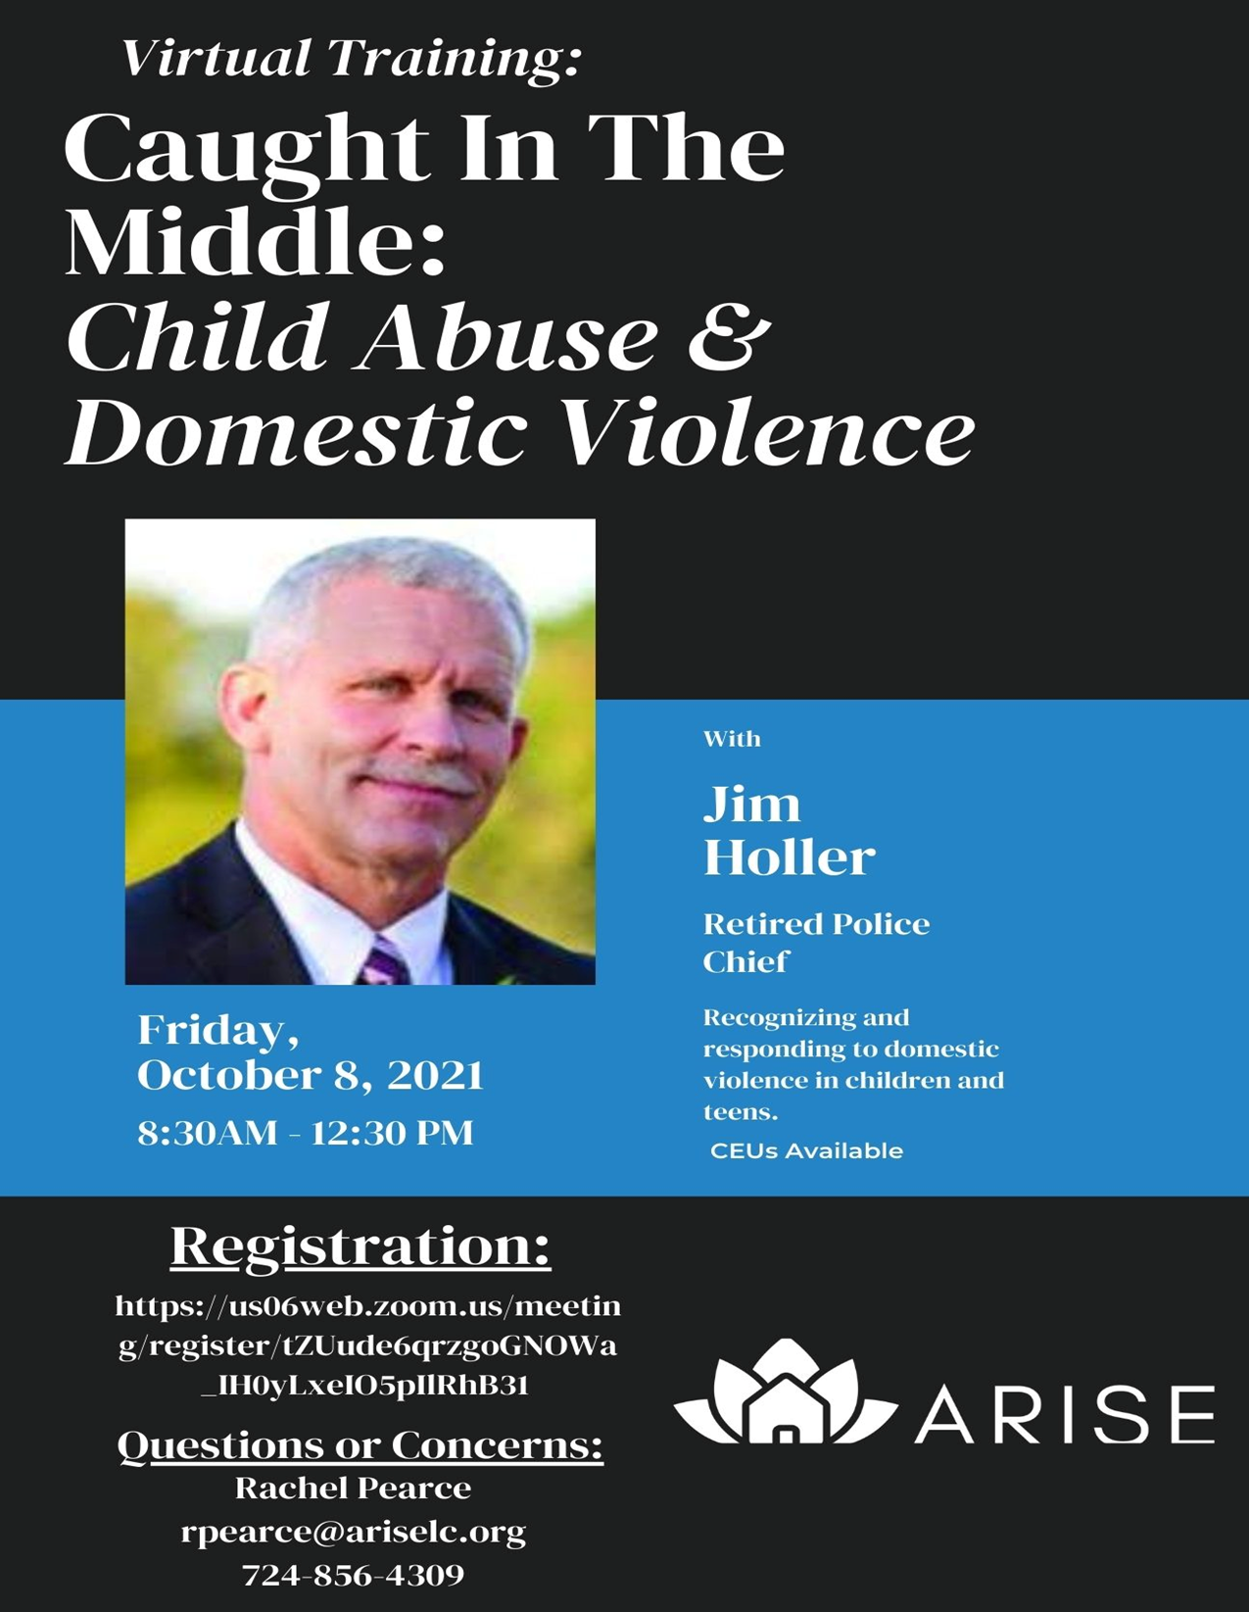

Please click here to register.

Return to top

Mentoring Youth Impacted By Sexual Exploitation

Join MENTOR, My Life My Choice, and Youth Collaboratory for information sharing and discussion around defining what sexual exploitation and its risk factors. We will discuss how to support youth who have experienced this or are at risk for experiencing it. We'll also discuss survivor-led programming, trauma-informed responses, and prevention. Participants will have the opportunity to ask questions and have smaller group conversations in this webinar.

Thursday, September 30 2:00 pm to 3:30 pm EST

Please click here to register.
Return to top

End Abuse Of People With Disabilities

New webinar series!
Focusing on gaps in addressing abuse,
vulnerable groups, racial justice and disability

FISA Foundation and Southwest PA Says No More are partnering with The Vera Institute of Justice's End Abuse of People with Disabilities initiative on a three-session interactive webinar series to bring together experts at the intersections of disability, domestic and sexual violence, campus violence, human trafficking, and racial justice.

See below for the complete list of co-sponsors.

Session 1 - Meeting the Needs of Human Trafficking Victims with Disabilities
September 28, 1:00-2:30 ET

People with disabilities (including autism and intellectual disabilities) are at high risk for both sex and labor trafficking, with many cases including an element that is unique to people with disabilities: traffickers stealing their government benefits, such as Supplemental Security Income or Social Security Disability Insurance. This session will explore the issues facing victims of trafficking who have disabilities, including the unique ways they are trafficked and implications for service providers.

REGISTER

Session 2 - From Classroom to Dorm Room:
Serving Survivors with Disabilities on Campus
October 20, 2:00-3:30 ET

Undergraduate students who have disabilities are nearly twice as likely as those without to report sexual violence. However, survivors with disabilities have been historically excluded by campus programs designed to prevent abuse and support survivors. This session will provide an overview on the barriers that student survivors with disabilities face in seeking out and receiving services on campus as well as solutions that educational institutions can implement to meet the needs of all students who experience sexual assault.

REGISTER

Session 3 - Transformative Justice in the Lives of Survivors with Disabilities
Date will be announced soon, early-mid November

With high rates of victimization and incarceration, people with disabilities have an elevated likelihood of having contact with the criminal legal system. This contact can be deadly, with 50% of people killed by police in the United States having a disability. This long history of being harmed by the state-sponsored justice system has led people with disabilities, and specifically people of color with disabilities, to seek alternative ways to heal and promote accountability. Transformative Justice (TJ) was created by and for people from marginalized communities to respond to violence when calling the police may not be a viable or safe option.

Co-Sponsors

• Autism Connection of Pennsylvania  • Black Girls Equity Alliance  • City of Pittsburgh Gender Equity Commission  • Gwen's Girls  • Institute on Disabilities at Temple University  • New Voices for Reproductive Justice  • Opportunity Fund | • Pittsburgh Center for Autistic Advocacy  • Pittsburgh Council on Higher Education (PCHE)  • Self Advocates United as 1  • SisTers PGH  • University of Pittsburgh School of Education  • UPMC Children's Hospital of Pittsburgh, Division of Adolescent and Young Adult Medicine

Southwest PA Says No More | Website | ‌

Return to top

Training Institute On Strangulation Prevention
One-day Virtual Strangulation Training: “The Last Warning Shot”

Presented by The Training Institute on Strangulation Prevention

Tuesday, September 28, 2021
8:00 a.m. to 5:00 p.m.

Please click here to register

Thursday, November 4, 2021
9:00 a.m. to 4:30 p.m.
Please click here to register

- Increase your understanding of the signs and symptoms of strangulation, short and long-term health consequences, need for imaging and a clinical exam;
- Improve system responses to the handling of non-fatal strangulation through multi-disciplinary teams;
- Increase awareness about current research, laws, best practices and resources;
- Improve the identification, investigation and documentation of strangulation cases across disciplines;
- Increase felony prosecutions and offender accountability;
- Reduce the number of strangulation cases being dismissed or reduced to misdemeanors simply because the victim recants or doesn’t appear in court;
- Improve victim safety through early intervention.
Return to top

Domestic Violence & Trauma Informed Care: Collaboration & Response To Survivors

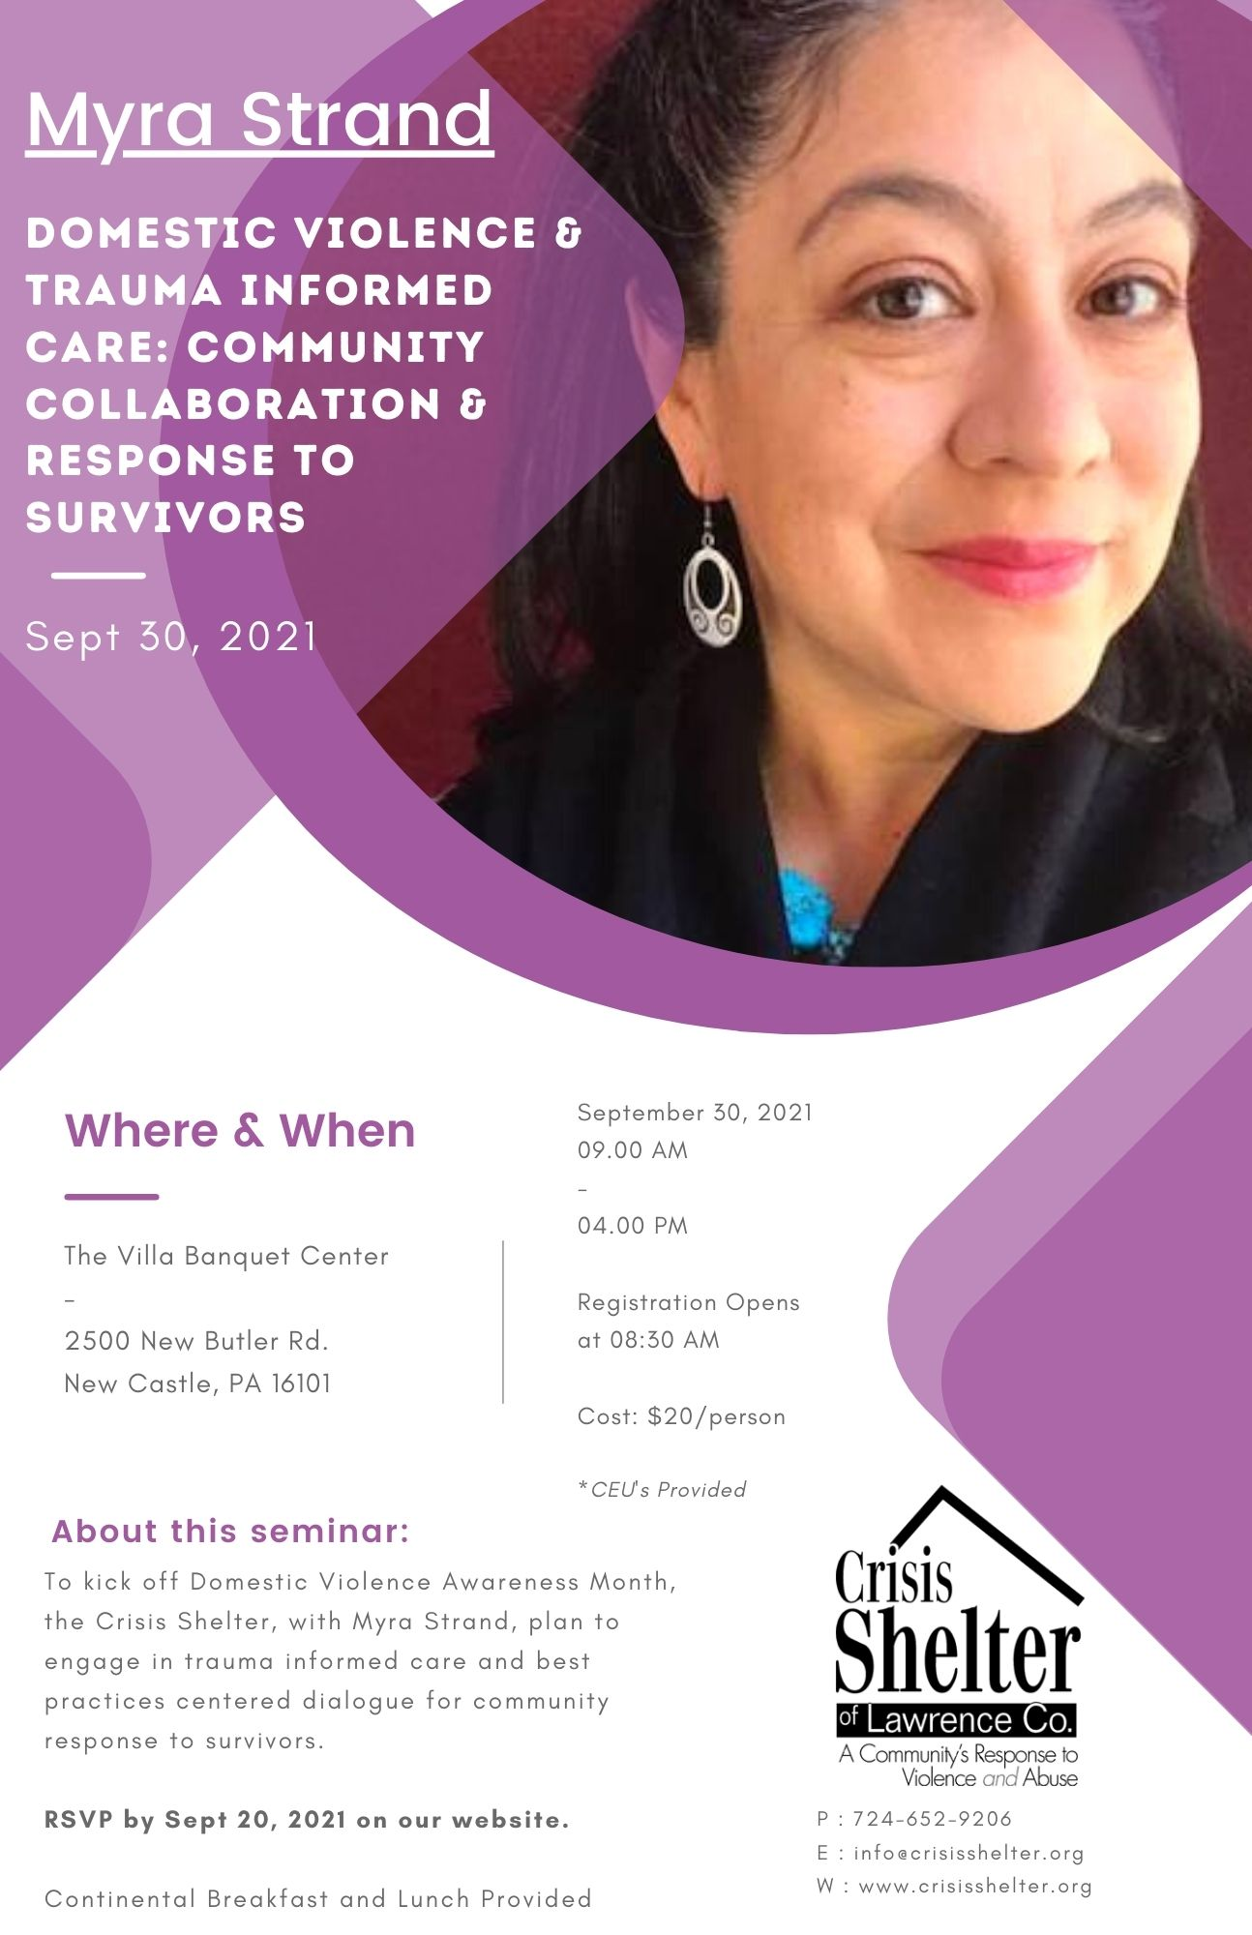

Please click here to register.

Return to top

Third Thursday Series

Addressing a Student’s Call for Help Through Suicide Risk Assessment
Oct 21, 2021 03:00 PM Eastern Time (US and Canada)
This session will review recognizing signs of suicide and address six best practices considerations for implementing Student Suicide Risk Assessments in K-12 schools. Learn how these practices can help improve and align the work of mental health professionals to effectively address the needs of students of concern with school safety in mind.
Presenters:
Will Gordillo, Sr. Education Associate, Public Consulting Group
Brittany St. Amand, Business Manager, Public Consulting Group
Please click here to register

How to Engage in Courageous Conversations
Nov 18, 2021 03:00 PM Eastern Time (US and Canada)
Current events in our nation have made it more important for leaders to engage in courageous conversations, even when they are difficult or make us feel uncomfortable. Engaging in open, authentic, truthful dialogue in an atmosphere of trust and respect is the key to effective leadership for improvement, especially on issues of race, gender, socioeconomics and other social justice topics. In this webinar, participants will understand how to create a safe space for courageous conversations to occur and strategies to initiate and facilitate meaningful interactions.
Presenter: Shileste Overton Morris, Ed.D., Director, Center for Schools and Communities
Please click here to register
Return to top

Victims Compensation Assistance Program Online Trainings

The following trainings will be held on September 21, 2021.
- Motor Vehicle-Related Crime Expenses Clinic - 9:30 a.m. – 10:30 a.m.
- Funeral & Burial Expenses Clinic – 2:00 p.m. – 3:00 p.m.

The following trainings will be held on September 27, 2021.
- Relocation Expenses Clinic - 2:00 p.m. – 3:00 p.m.

The following trainings will be held on September 28, 2021.
- Stolen Benefit Cash Expenses Clinic - 2:00 p.m. – 3:00 p.m.

The following trainings will be held on October 5, 2021.
- Crime Scene Cleanup Expenses Clinic – 9:30 a.m. – 10:30 a.m.
- Counseling Expenses Clinic – 2:00 p.m. – 3:00 p.m.

The following trainings will be held on October 12, 2021.
- Basic Compensation -10:00 a.m. –12:00 p.m.

The following trainings will be held on October 28, 2021.
- Loss of Earnings Clinic - 9:30 a.m. – 10:30 a.m.
- Medical Expenses Clinic – 2:00 p.m. – 3:00 p.m.

All trainings count towards 1 hour of the required RASA/VOCA/VOJO training hours, except Basic Compensation which counts towards 2 and DAVE training which counts towards 2.15.

Please click here to register.

Return to top

Central Division Victim Services – Employment Opportunities

Central Division Victim Services (CDVS) is to foster a safe, prosperous, and resilient community with a focus of advocating for safe neighborhoods while supporting survivors of trauma due to violence.

Please click here to view current job opportunities
Return to top

PAAR – Employment Opportunities

Pittsburgh Action Against Rape was incorporated as a non-profit entity in 1972 and has been providing essential no-cost services to victims of sexual violence in Allegheny County for over 49 years, and is the only agency solely devoted to the issue of sexual violence.

Please click here to view current job opportunities.
Return to top

Neighborhood Legal Services – Employment Opportunities

Neighborhood Legal Services Association (NLS) was established in 1966 as a non-profit, public interest law firm to provide civil legal assistance to poor and vulnerable residents of Allegheny (and later) Beaver, Butler and Lawrence Counties.

Please click here to view current job opportunities
Return to top

Mission Kids – Employment Opportunities

Mission Kids Child Advocacy Center of Montgomery County is expanding our team! Our mission is to achieve healing and justice for victims of child abuse by providing collaborative services, advocacy, leadership and education.

Please click here to view current job opportunities
Return to top

YWCA Greater Harrisburg – Employment Opportunities

The YWCA Greater Harrisburg is dedicated to eliminating racism, empowering women and promoting peace, justice, freedom and dignity for all.

Please click here to view current job opportunities
Return to top

Safe Berks – Job Opportunities

Safe Berks provides safe haven and support to victims of domestic violence and sexual assault. Our advocacy and education programs increase awareness of oppression and promote the prevention of domestic violence and sexual assault.
Please click here to view current job opportunities.
Return to top

Network of Victim Assistance – Employment Opportunities

Network of Victim Assistance (NOVA) is a nonprofit organization serving victims of sexual assault and other crimes. Located in Bucks County, PA, NOVA is the comprehensive victim services organization in Bucks County. With a 45-year history, NOVA has expanded to include a continuum of prevention and direct services to prevent and address the needs of victims of sexual abuse and other serious crimes. NOVA is known across many disciplines and the community at large for its exceptional services and professionalism. With a 4.5-million-dollar operating budget, NOVA continues to grow. As a mature and fiscally sound organization, establishing sustainability is key to our future success -- serving all victims who need services, educating the community at large on violence prevention in our community, and providing top-ranked professional trainings.

Please click here to view current job opportunities
Return to top

Blackburn Center – Employment Opportunities

Blackburn Center advocates for the rights of all individuals to live free from domestic and sexual violence and other forms of violence by eliminating the root causes of this violence and providing for the well-being and safety of survivors/victims.

Please click here to view current job opportunities.
Return to top

If your program is offering new or extended services, or implementing new initiatives that you would like to highlight, please submit your news article to Lea Dorsey at ledorsey@pa.gov.

The next OVS Newsletter will be published on Wednesday, October 6, 2021. If you would like any training events, fundraisers, or notable news published in this newsletter, please submit them to Lea Dorsey at ledorsey@pa.gov by Wednesday, September 29, 2021.

You have signed up to receive the OVS Newsletter from the Office of Victims' Services. This newsletter will be sent to you on a biweekly basis via email. If your email address changes or you would like to be removed from the OVS Newsletter distribution list, please contact Lea Dorsey at (717) 265-8733 or via email at ledorsey@pa.gov.
Return to top
Pennsylvania’s Office of Victims’ Services | 3101 North Front Street | Harrisburg, PA 17110 | (717) 783-0551
www.pccd.pa.gov
PA Crime Victims Website
www.pcv.pccd.pa.gov
Twitter: @PaCrimeComm.

