Charles Ramsey
Chairman
Derin Myers
Acting Executive Director

OVS Newsletter
March 1, 2017

In this Issue...
- Remembering Princess, The Children’s Advocate (June 1, 2005 to February 22, 2017)
- Registration For The 14th Pathways For Victim Services Conference Is Now Open!
- SAM & DUNS Registration Warning
- Training Announcement: Fostering Positive Relationships With Law Enforcement
- New Report From Common Justice: Accounting For Violence: How To Increase Safety And Reduce Our Failed Reliance On Mass Incarceration
- What Could Happen If The Violence Against Women Act Is defunded?
- New FBI Wanted App: Making It Easier To Find Fugitives And Missing Persons
- Victims Compensation Assistance Program Online Trainings
- Pennsylvania Coalition Against Rape (PCAR) – Request for Proposals
- PDAI Victim Services Training News
- Scholarships Available For 2017 National Victim Service Conferences
- Save The Date: Crime Victims’ Rights Rally
- Save The Date: 4th Annual Victims’ Rights Conference
- Save The Date: The 14th Pathways For Victim Services Conference
- Save The Date: Second Annual Bucks, Montgomery, And Philadelphia County Regional Forensic Nursing Conference
- Save The Date: KCIT Basic Crisis Response Training

Upcoming Events
  - WebEx Online Trainings Available
Compensation Related: Basic, Advanced-Counseling, Transportation Expenses, Restitution and much more!
Credits towards VOCA/RASA/VOJO training requirements are available for all sessions (unless indicated otherwise in the session description). To receive training credits: 1) you must be logged into the session and 2) the WebEx application must be on your computer for the entire duration of the session. As the OVS recognizes that emergencies may arise and you may not be able to attend the entire session, there is no prohibition against attending part of a session (although training credits will not be given in that instance).
  - Training/Networking Opportunities
  - Additional RASA/VOJO/VOCA Approved Training
Return to top

Remembering Princess, The Children’s Advocate (June 1, 2005 to February 22, 2017)

District Attorney Stacy Parks Miller shares the regrettable news that the office’s beloved furry guardian of children, Princess, has gone on to the rainbow bridge. For the last seven years, Princess has been lighting up the lives of the employees of the DA’s Office, the Courthouse, and most importantly, comforting children and adult victims at the Centre County Courthouse. 11½ year-old Princess came to work at the Centre County DA’s Office in January of 2010, when DA Stacy Parks Miller took office. She dutifully provided companionship and comfort to crime victims, even sitting in the witness box with them while they testified against their assailants.

Princess, the DA Children’s Dog, passed away Wednesday morning shortly after arriving at work to provide accompaniment to 2 young children victims who were to testify that morning in Court during sexual assault cases. Princess suddenly began to show symptoms that required a trip to the vet. It was discovered that Princess developed a serious medical problem from which she could not recover.

Princess was the first Comfort dog for victims utilized on the East Coast. In her extraordinary lifetime, Princess has served over 400 victims. While she was originally acquired for children, the office quickly realized her skill was invaluable for witnesses of all ages, and she began dutifully comforting both adults and children through the difficult court process. When she was meeting with victims who would become tearful, she would start to make little empathy cries, almost quietly, with her head resting on their laps as she leaned in to them. It was remarkable.

Please know during her 11½ years she was very happy, and deeply loved by many. We thank the wonderful Courthouse employees who treated her like family. We could barely walk to the courtroom without her detouring into offices to receive her “special treats” from special friends. Just that morning, she was playing with her puppy sibling before happily arriving to work. She was working only very part time at this stage of her life.

She will be remembered for her 7 years of faithful service to victims of crime. Princess received her basic obedience skills at The Puppy Program in the State Correctional Institute at Cambridge Springs, an inmate-based program supervised and sponsored by the Canine Partners for Life (CPL) organization, Cochranville, PA. She was originally trained by a female inmate to be a service dog to help children with disabilities. Afterwards, she was assigned to a young boy with physical disabilities. When the boy developed allergies to Princess, CPL had to cease their connection, and the yellow lab was re-purposed as a Courthouse Canine.

Her true “’mother” is Victim Advocate Faith Schindler. Faith is both Princess’s handler and mom. Faith worked to obtain Princess and learned to handle her through a partnership with Canine Partners for Life. As she was the first of her kind on the east coast, other visiting counties’ District Attorney’s Offices were so inspired by Princess that they have since either obtained or started the process to obtain a comfort dog like her. Montgomery County was one such county that acquired its own companion dog after meeting Princess.

Princess has met the governor and sat on the Judge’s bench. She could open doors, high five kids, and lay her head on their laps so they could more easily choke out the necessary words to describe the horrible things their abusers—in some cases, their own relatives—have done to them. She was a hero, even when she stole lunches out of the office’s garbage cans. In 2006, Princess was recognized for her hard work as the Honoree at Centre County PAWS’ 6th Annual Fur Ball.

Princess came from a litter of service dogs. Her brothers worked locally as well. One was trained in bomb detection and was employed for a time at The Pennsylvania State University. Another was trained in drug detection and was employed by the Pennsylvania State Police.

District Attorney Stacy Parks Miller said, “Princess was our girl, your girl, everyone’s girl. She spoke to a lot of people without using voice. We are currently lost without our golden girl around here.”

The District Attorney’s Office wishes to thank Fred Metzger and his Hospital for loving and personal, charitable care of Princess throughout her life and Wiscoy Pet Food Co. for their generous donations of medical care and food supplies. Without them, we could not have helped all of Centre County’s children.

The DA’s Office does plan to continue providing companion animals for both adult and child victims of crime, and had already had initiated the process to obtain a new dog when Princess began her well-earned semi-retirement several months ago.

Princess is pictured below with her beloved mom and handler, Faith Schindler; hard at work at the Courthouse; and with Mom and District Attorney Stacy Parks Miller.

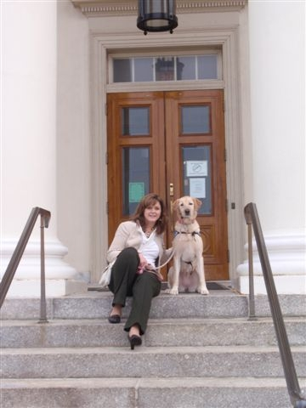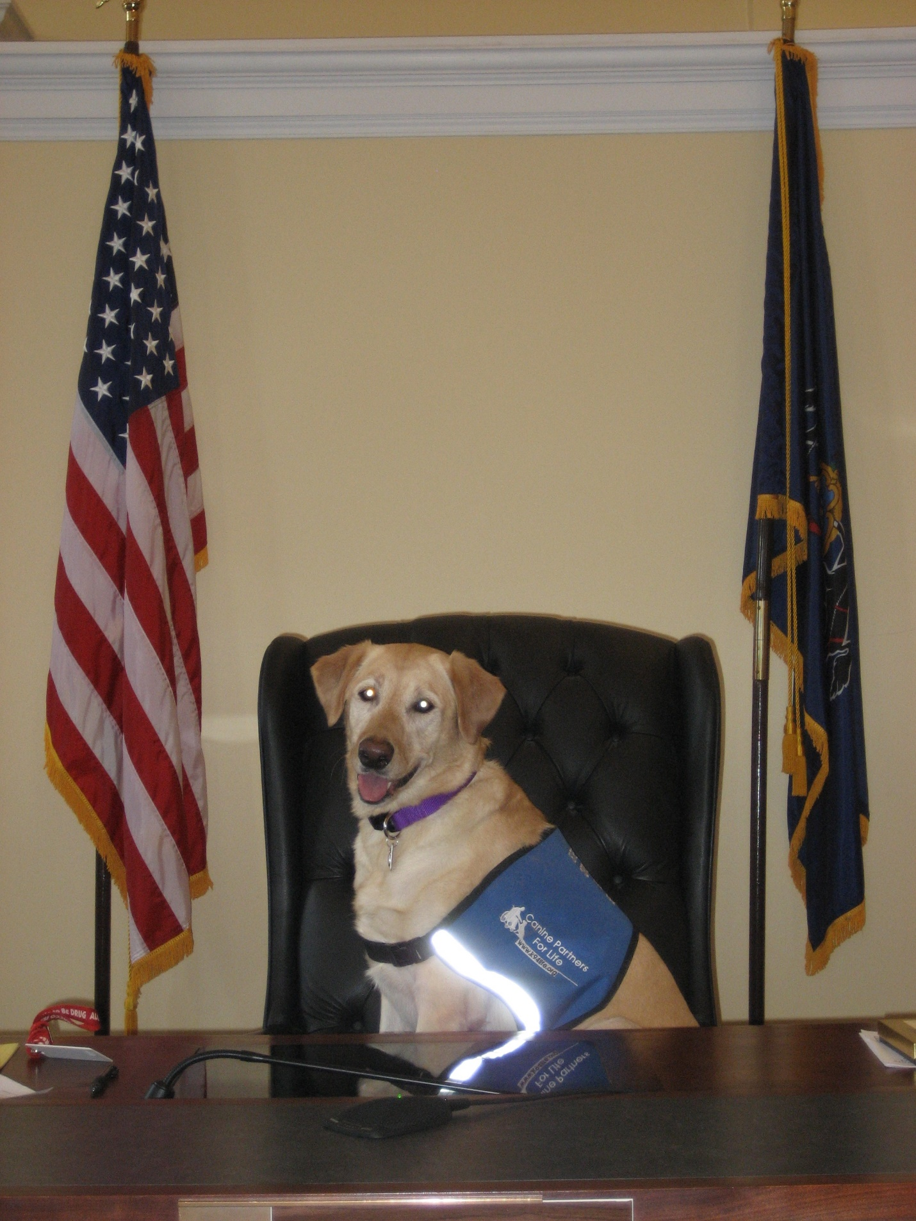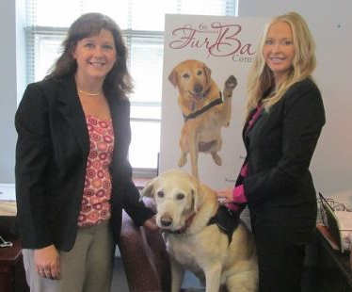

Return to top

Registration For The 14th Pathways For Victim Services Conference Is Now Open!

OVS is pleased to announce that registration is NOW OPEN for the 2017 Pathways for Victim Services Conference.
The conference will be held at the Hershey Lodge and Conference Center in Hershey, PA on the following dates:
Monday, May 8, 2017
Tuesday, May 9, 2017
Wednesday, May 10, 2017
OVS is very excited about the upcoming Pathways Conference and we look forward to seeing you there!
To view event details and to register online, please click here.
Return to top

SAM & DUNS Registration Warning

PCCD has recently become aware of a scam that entices recipients of grant funds to pay a fee to either:
- Register or renew their current registration in the federal System for Award management (SAM); or
- Obtain a DUNS number for their agency

Please be aware that there is never a cost to register or renew in the federal SAM or obtain a DUNS number.

The websites below are the correct websites for SAM and Dun and Bradstreet (DUNS number):

SAM: https://www.sam.gov/portal/SAM/

Dun and Bradstreet (DUNS number): https://www.dandb.com/. Choose D&B D-U-N-S Number and then choose a Free D-U-N-S Service.

You may email RA-PCCDGrantsMgmt@pa.gov with any questions.
Return to top

Training Announcement: Fostering Positive Relationships With Law Enforcement

This is a great collaborative project between law enforcement and the local rape crisis center!

This module is intended for community members, caseworkers, advocates, and other social service members who have regular contact with the law enforcement officers. Participants are introduced to a general background of many police officers and offered explanations for their behaviors. The instruction provides participants with actionable resources to improve interactions with police officers in a variety of professional situations. Participants learn how to build rapport with law enforcement officers of all ranks and how to manage a situation where they encounter “a problem officer.” A series of common occurring obstacles are deconstructed and a variety of possible solutions offered. The module concludes with an interactive question and answers session.

Training Details:
April 4th, 2017 from 1:00 – 4:00pm
YWCA Lancaster
110 N. Lime Street
Lancaster, PA 17602

The fee is $60 per person. Please contact Lisa Cameron at lcameron@ywcalancaster.org to register.
Return to top

New Report From Common Justice: Accounting For Violence: How To Increase Safety And Reduce Our Failed Reliance On Mass Incarceration

Common Justice published a report, Accounting for Violence: How to Increase Safety and Break Our Failed Reliance on Mass Incarceration, which outlines what it would take to responsibly address and reduce violence without relying on prison. It is argued that any response to violence should be centered on survivors, based in accountability, driven by safety, and racially equitable. The report’s recommendations include the elimination of mandatory minimums to make way for alternative options that better meet survivors’ needs and increase safety; the expanded use of restorative justice; the investment of public resources into strategies that target the core drivers of violence—including poverty, housing instability, inequity, and trauma; and the expansion of access to victim services, including ways that don’t require engaging with law enforcement. To read the report, please click here.

Danielle Sered, Director of Common Justice (an organization that operates an alternative-to-incarceration and victim service program for serious and violent felonies) authored an op-ed in the Washington Post, How To Curb Violence, And Mass Incarceration, By Focusing On Crime Victims, which can be found here.
Return to top

What Could Happen If The Violence Against Women Act Is defunded?
Since 1994, programs supported through the Violence Against Women Act (VAWA) legislation have infused federal dollars into state and local efforts to prevent, investigate, and prosecute domestic violence and sexual assault and help survivors rebuild their lives. The funding doesn’t just assist victims. It also assists law enforcement and prosecutors by providing training and enhancing resources for investigation and prosecution of these violent crimes. If these funds become unavailable to states and local communities, it could stifle efforts to address these crimes. The Hill recently reported that members of the Trump administration were using the Heritage Foundation’s budget recommendations to guide their funding plans. Heritage calls for eliminating the VAWA grant programs that help protect victims and hold those who commit these crimes accountable. Please click here to read more.
Return to top

New FBI Wanted App: Making It Easier To Find Fugitives And Missing Persons
You’re watching your local news on TV when you see a story on a wanted fugitive in your community. The person looks like someone you’ve seen living a few blocks away. You grab your cell phone, open the FBI Wanted app, search your city name, and quickly locate the individual’s profile with additional pictures and information. The similarity is striking. So you tap the “Call the FBI” button in the app and report what you know.
This situation illustrates exactly the kind of technology-driven crime fighting that is now possible—thanks to a new FBI Wanted mobile application launching today. The app allows the public to view, search, sort, filter, and bookmark the full range of information issued by the FBI. That includes pictures and descriptions of wanted fugitives, missing persons, crime suspects, deceased victims, and others the Bureau is seeking to locate or identify. Please click here to read more.
Return to top

Victims Compensation Assistance Program Online Trainings

The following training will be held on March 2, 2017.
- ”Wow, That’s Covered by Compensation” - 9:30 a.m. – 10:30 a.m. Click here to register.

The following training will be held on March 7, 2017.
- Motor Vehicle-Related Crime Expenses Clinic - 9:30 a.m. – 10:30 a.m. Click here to register.

The following training will be held on March 9, 2017.
- Relocation Expenses Clinic - 9:30 a.m. – 10:30 a.m. Click here to register.

The following training will be held on March 14, 2017.
- Stolen Benefit Cash Expenses Clinic - 9:30 a.m. – 10:30 a.m. Click here to register.

The following trainings will be held on March 22, 2017.
- Restitution Basics - 10:00 a.m. – 11:00 a.m. Click here to register.
- Loss of Earnings Clinic - 11:30 a.m. – 12:30 p.m. Click here to register.
- Loss of Support Clinic - 1:00 p.m. – 2:00 p.m. Click here to register.

The following training will be held on March 28, 2017.
- Transportation Expenses Clinic - 9:30 a.m. – 10:30 a.m. Click here to register.

The following training will be held on April 5, 2017.
- Basic Compensation - 10:00 a.m. – 12:00 p.m. Click here to register.
- Counseling Expenses Clinic - 1:00 p.m. – 2:00 p.m. Click here to register.

The following DAVE trainings will be held in 2017:
- 4/13/17 DAVE Training - 1:00 p.m. – 3:00 pm. Click here to register.

- All trainings count towards 1 hour of the required RASA/VOCA/VOJO training hours, except Basic Compensation which counts towards 2 and DAVE training which counts towards 2.15.
Return to top

Pennsylvania Coalition Against Rape (PCAR) – Request for Proposals

The Pennsylvania Coalition Against Rape (PCAR) will be accepting Requests for Proposals (RFP) to provide services related to sexual violence in communities throughout Pennsylvania. This competitive application is for Fiscal Year 2017-2018 with yearly renewals through Fiscal Year 2021-2022. The RFP will be made available February 3, 2017 on the PCAR website (www.pcar.org). All RFPs must be submitted electronically. Organizations wishing to apply will have until March 10, 2017 to submit an application to PCAR.
Return to top

PDAI Victim Services Training News

Registration is open for the following one-day training:

Supporting Victims of Elder Abuse
March 16, 2017
Philadelphia District Attorney’s Office
Ray Harley Training Room
3 South Penn Square Philadelphia, PA
Registration for this training will begin at 8:30 and the training will be conducted from 9:00 am to 4:30 pm.
Registration is $25.00 and you can register here.

April Foundational Academy
April 19-21, 2017
The registration for this training is now closed. If you would like to be placed on a waiting list, please email Donna R. Hull at donna@dhullconsulting.com.
- For those who have already registered, the online independent study component is available here.
Pennsylvania Protection Acts – What You Need to Know
This training was recorded and is available here. The password to view this training is FEB#817.
Return to top

Scholarships Available For 2017 National Victim Service Conferences
The Pennsylvania District Attorneys Institute (PDAI) is pleased to announce the availability of funding for scholarships to attend eligible national victim service conferences. This funding is made available through a grant awarded to PDAI by the Pennsylvania Commission on Crime and Delinquency (PCCD) for the purpose of subsidizing the costs associated with attending these training conferences. These costs may include registration fees, per diem (for food), and reasonable transportation and lodging expenses. The scholarships are only available to victim service professionals to attend any national conference focused on victim service training. To qualify, the applicant’s entire job focus must be on providing support, information, and assistance to victims. Any eligible conference must be completed within the 2017 calendar year. Only one person per agency can receive a scholarship and only after providing a sufficient justification of need. Recipients are selected based upon the information provided in the application, the number of scholarships previously awarded, and remaining available funding. Please click here for the Scholarship Application.
Return to top

Save The Date: Crime Victims’ Rights Rally

When: April 3, 2017 at 11 a.m.
Where: Capitol Rotunda, Harrisburg, PA
Please click here to view or print the Save the Date.
Return to top

Save The Date: 4th Annual Victims’ Rights Conference
Crime Victim Center is hosting our 2017 "Crime Victims' Rights Conference: Strength; Resilience; Justice" on Friday, April 28th, from 9am to 4:15pm, at the Bayfront Sheraton in Erie, PA. Seating is limited to the first 75 people to register.

This conference will host a range of amazing speakers in three breakout sessions, in addition to a speaking program during lunch.

Event Location:
Bayfront Sheraton
55 W Bay Rd,
Erie, PA 16507

For more information or to register, please click here.
Application has been made for continuing education credits for Nursing Home Administrator and Activity Professionals as well as Social Work, Marriage and Family Therapists and Professional Counselors.
Return to top

Save The Date: The 14th Pathways For Victim Services Conference
OVS is pleased to announce the dates of the next Pathways for Victim Services Conference in 2017. The conference will be held in the spring of 2017 at the Hershey Lodge and Conference Center in Hershey, PA.
Please mark your calendars for the following dates:
Monday, May 8, 2017
Tuesday, May 9, 2017
Wednesday, May 10, 2017
OVS is very excited about the upcoming Pathways Conference and we look forward to seeing you there! For additional information, please click here.
Return to top

Save The Date: Second Annual Bucks, Montgomery, And Philadelphia County Regional Forensic Nursing Conference

Friday, May 12th, 2017
Abington Jefferson Health
1200 Old York Road
Abington, PA 19001
8:00am – 5:00pm
Please click here to view or print the Save the Date

Topics Include
• Cultural and medical considerations for transgender individuals during a medical-forensic exam
• Courtroom testimony techniques
• Trends in forensic serology and DNA technology
• Campus sexual assault
• Sexual Assault: The police Investigation Perspective
• Role of the forensic nurse coroner
• Best practices in SANE case review and peer review

Speakers Include
- Dr. Rachel Levine, Physician General of Pennsylvania and Professor of Pediatrics and Psychiatry at the Penn State College of Medicine
- Ron Smith, forensic identification and investigation specialist
- Pennsylvania State Police Crime Lab
- Jonathan Kassa, Director of Higher Education for Allied Universal
- Detective Dave Bonaquisti, Warminster Police Department, Bucks County, PA
- Pamela Gay, RN, York County, PA Coroner
- Jana French, Nursing Director of Washington DC Sexual Assault Nurse Examiner Program and International Association of Forensic Nurses (IAFN) Board Member
We will be applying for CEUs for Registered Nurses and Social Workers
Return to top

Save The Date: KCIT Basic Crisis Response Training

June 19-22, 2017
Country Inn & Suites by Carlson
State College, PA
Training Fee: $250 (Fee includes hotel accommodations, training materials, breakfast and lunch each day)
Application Deadline: May 12, 2017
Please click here to register and for more information.
This training is sponsored by the Keystone Crisis Intervention Team. KCIT provides crisis intervention services to victims of crime and their communities in the aftermath of a traumatic event in Pennsylvania.
This 25 hour course trains qualified individuals to work as a team with the goal of helping people in crisis cope with the physical, emotional, and behavioral reactions to trauma in the aftermath of a community crisis.
Please note: Completion of this application does not secure a seat in the training. You will be notified if you have been selected for this training course. All applicants will be notified by May 19, 2017 if they were accepted into the training. Decisions are based on several factors.
For more information or questions please contact: Michelle Kern, KCIT Coordinator at 215-343-6543, or by email at michelle@novabucks.org
- This training has been approved for 25 PCCD training hours.
- This training has applied for approval by the State Board of Social Workers, Marriage and Family Therapists, and Professional Counselors for 25 CEUs.
- Funding for this project is made available in part through the Pennsylvania Commission on Crime and Delinquency (PCCD).
Return to top

The next OVS Newsletter will be published on Wednesday, March 15, 2017. If you would like any training events, fundraisers, or notable news published in this newsletter, please submit them to Heather Hewitt at hhewitt@pa.gov by March 8, 2017.

You have signed up to receive the OVS Newsletter from the Office of Victims' Services. This newsletter will be sent to you on a biweekly basis via email. If your email address changes or you would like to be removed from the OVS Newsletter distribution list, please contact Heather Hewitt at (717) 265-8730 or via email at hhewitt@pa.gov.

Pennsylvania’s Office of Victims’ Services | 3101 North Front Street | Harrisburg, PA 17110 | (717) 783-0551
www.pccd.pa.gov
PA Crime Victims Website
www.pcv.pccd.pa.gov
Twitter: @PaCrimmCom

