Charles Ramsey
Chairman
Michael Pennington
Executive Director

OVS Newsletter
October 23, 2019

In this Issue...
- Victims Compensation Online Trainings
- Resources & Training Materials – Aequitas
- Adverse Childhood Experiences and Trauma
- “Start by Believing” Day is April 1st – End Violence Against Women International (EVAWI) are Collecting Personal Stories from Sexual Assault Survivors.
- She Was Sex-Trafficked and Then Criminally Charged. Now She’s Asking for a Pardon
- Survey Finds Evidence of Widespread Sexual Violence at Thirty-Three Universities
- Domestic Violence Counts: Thirteenth Annual Census Report
- Children’s Exposure to Crime Costs U.S. $458B a Year: Study
- Here’s Why Domestic Violence Kills So Many Women and Children in America

Upcoming Trainings
- The Hidden Crime of Human Trafficking in Rural Communities and the Health Care System & Community Response
- National Coalition Against Domestic Violence Webinar – DVAM is 365 Days Long: How to Raise Awareness of Domestic Violence During and Beyond October
- Rapid Rehousing for Domestic Violence Victims: A Formative Evaluation Webinar
- PA Immigration Resource Center Webinar – Bilingual Staff’s Role in Language Access
- OVC TTAC Webinar – Courageous Spirit: The Effects of Historical Trauma on AI/AN Communities
- The North Eastern Pennsylvania (NEPA) Task Force Against Human Trafficking – Regional Training
- STOP Domestic Violence Trainings Across PA
- PA Immigration Resource Center Webinar – Hiring, Retaining and Supporting Bilingual Staff at Your Organization
- PDAI Victim Services Trainings

Conferences
- 2019 Pathways for Victim Services

Upcoming Events
  - WebEx Online Trainings Available
Compensation Related: Basic Compensation and much more!
Credits towards VOCA/RASA/VOJO training requirements are available for all sessions (unless indicated otherwise in the session description). To receive training credits: 1) you must be logged into the session and 2) the WebEx application must be on your computer for the entire duration of the session. As the OVS recognizes that emergencies may arise and you may not be able to attend the entire session, there is no prohibition against attending part of a session (although training credits will not be given in that instance).
  - Training/Networking Opportunities
  - Additional RASA/VOJO/VOCA Approved Training
Return to top

Victims Compensation Online Trainings
October 24, 2019
Restitution Basics 10:00a.m. – 11:00a.m.
October 29, 2019
Funeral & Burial Expenses Clinic 9:30 a.m. – 10:30 a.m.
Crime Scene Cleanup Expenses Clinic 11:00 a.m. – 12:00 p.m.
November 12, 2019
Basic Compensation 10:00 a.m. – 12:00 p.m.
Click here to register for the above trainings.

November 19, 2019
DAVE Webex Training 1:00 p.m. – 3:15 p.m.
Click here to register for this training.
All trainings count towards 1 hour of the required RASA/VOCA/VOJO training hours, except for Basic Compensation, which counts towards 2 training hours, and DAVE training, which counts towards 2.15 training hours.
Return to top

Resources & Training Materials – Aequitas
Aequitas develops and publishes a wide range of resources and training materials on topics related to the investigation and prosecution of gender-based violence and human trafficking.
Click here to read more.
Return to top

Adverse Childhood Experiences and Trauma
Seventy percent of adults in the U.S. have experienced at least one form of traumatic event in their lives.
Traumatic childhood experiences have a significant impact on individuals and the consequences can affect entire communities, making it a serious public health issue. Trauma is defined as a person’s response to one or multiple events that are physically or emotionally harmful or threatening. Many events that cause trauma include natural disasters, childhood abuse or neglect, sexual assault, and other forms of violence, which can have a lasting effect on behavior and health. If left unaddressed, these traumatic experiences can increase the likelihood of individuals developing mental illnesses, substance use disorders, and other mental and physical health conditions that affect the overall quality of life.
Click here to read more.
Return to top

“Start by Believing” Day is April 1st – End Violence Against Women International (EVAWI) are Collecting Personal Stories from Sexual Assault Survivors.
When sexual assault victims turn to us, we know that every response matters. The responses of friends and family members matter. The responses of police officers, nurses, and advocates matter. Simply put, every response to a sexual assault victim matters, because it can have a powerful impact on their healing process and pursuit of justice.
With this in mind, the theme for our 5th Annual Start by Believing Day is: Every Response Matters – Share Yours!
Click here to read more.
Return to top

She Was Sex-Trafficked and Then Criminally Charged. Now She’s Asking for a Pardon
Hope Zeferjohn’s soon-to-be pimp found her 100 miles away from where they had met through her family. He had pretended to be her father so authorities would tell him where she now lived.
Zeferjohn was a teen, living in Salina, Kansas, where she was in the state’s juvenile offender program for a misdemeanor battery charge after growing up in Topeka, according to KCUR and the Topeka Capital-Journal. She and the trafficker, Anthony Long, fell into an abusive relationship. Long sold videos of them having sex and forced Zeferjohn to recruit other girls for prostitution, KCUR reported.
Click here to read more.
Return to top

Survey Finds Evidence of Widespread Sexual Violence at Thirty-Three Universities
About one-quarter of undergraduate women say they have been victims of sexual touching or penetration without consent since starting college, according to a survey this year on sexual assault and misconduct at 33 major universities.
The survey released Tuesday was the second from the Association of American Universities in recent years to document the disturbing prevalence of sexual violence at prestigious public and private schools. A 2015 study involving many of the same universities found broadly similar patterns of sexual misconduct.
Click here to read more.
Return to top

Domestic Violence Counts: Thirteenth Annual Census Report
For the thirteenth consecutive year, on September 13, 2018, the National Network to End Domestic Violence (NNEDV) conducted a one-day unduplicated count of adults and children seeking domestic violence services in the United States. This annual census documents the number of individuals who sought services in a single 24-hour period, as well as the types of services requested, the number of service requests that went unmet due to a lack of resources, and the issues and barriers that domestic violence programs face as they strive to provide services to victims of domestic violence. This report is instrumental in raising awareness about domestic violence and the incredible work that local domestic violence programs do every day.
Click here to read more.
Return to top

Children’s Exposure to Crime Costs U.S. $458B a Year: Study
Childhood exposure to violent crime costs American society $458 billion a year, according to a University of Pennsylvania study.
Building on their previous broad analysis of crime’s impact on children, authors Michal Gilad of the University of Pennsylvania Leonard Davis Institute of Health Economics, and Abraham Gutman, a staff writer with the Philadelphia Inquirer, quantified the consequences of that impact in areas ranging from health and lost unemployment, to the cost of treatment for substance abuse, to come up with what they said was still a “conservative” estimate.
Click here to read more.
Return to top

Here’s Why Domestic Violence Kills So Many Women and Children in America
La’Shea Cretain had just finished feeding her 4-month-old daughter when her ex-boyfriend arrived unannounced at the home in Opelousas, Louisiana, that she was visiting and shot her in the head before killing himself. Cretain, who was 18 at the time, collapsed at the front door, just feet from her infant daughter and toddler son.
Twenty-three years later, Cretain still suffers from chronic pain and back issues from the five bullets stuck in her body, including one lodged in her spine. That’s on top of the emotional trauma she and her children—who grew up knowing their mother was nearly killed in their presence—have had to grapple with since the shooting on October 3, 1996. “We’ll never be the same,” says Cretain, who is now a 41-year-old gun violence prevention advocate. “This is just something that will be with us.”
Click here to read more.
Return to top

The Hidden Crime of Human Trafficking in Rural Communities and the Health Care System & Community Response
On October 29, 2019, The Pennsylvania Office of Rural Health, in partnership with the Region III Office of the Health Resources and Services Administration, U.S. Department of Health and Human Services, the Eastcentral and Northeast Pennsylvania Area Health Education Center, and the Pennsylvania Coalition Against Rape, is offering this one-day continuing education and outreach event to continue a rural human trafficking collaborative with an emphasis on rural prevention, treatment, and community collaboration.
Join us to hear stories from victims of human trafficking and learn about the impact of this crisis in Pennsylvania, the role of law enforcement, and how health care providers are trained to identify victims of human trafficking and how community partnerships address this pervasive issue.
Click here to register.
Return to top

National Coalition Against Domestic Violence Webinar – DVAM is 365 Days Long: How to Raise Awareness of Domestic Violence During and Beyond October
Join the National Coalition Against Domestic Violence (NCADV) and the National Resource Center for Domestic Violence (NRCDV) for a FREE webinar. You’ll learn more about these organizations’ Domestic Violence Awareness Month campaigns, how to utilize available tools and resources to make these campaigns relevant to your audience and how to integrate DVAM into your policy and educational work to make DVAM’s impact last beyond October.
For additional information and to register, please click here.
Return to top

Rapid Rehousing for Domestic Violence Victims: A Formative Evaluation Webinar
The Center for Victim Research invites you to attend its upcoming free webinar, “Rapid Rehousing for Domestic Violence Victims: Examining Two Approaches" on October 29th at 2 pm EST. Victim advocates and funders recognize the need for effective programs to provide swift housing solutions to survivors of domestic violence. The 2016 VOCA Rule change permitted greater flexibility in funding transitional housing programs for victims. Evaluation of the various housing models is a critical step toward achieving desired outcomes for victims. Two research collaborations between VOCA Administrators and their state Statistical Analysis Center, in Iowa and Maine, recently undertook formative evaluations of specific rapid rehousing programs for domestic violence victims. Presenters will describe the steps they took, findings from these early examinations, and lessons learned about researching in this area.
Click here to register.
Return to top

PA Immigration Resource Center Webinar – Bilingual Staff’s Role in Language Access
On Wednesday, November 13, 2019, PIRC is offering a webinar geared toward bilingual domestic and sexual violence victim advocates and volunteers. Participants will explore the role of bilingual staff in your organization’s language access plan, identify and distinguish the roles of bilingual staff and of interpreters, and examine strategies for advocating towards improved language access within and outside one’s organization and for upholding professional boundaries of bilingual advocates, staff and volunteers.
Presenter’s Bio: Ana I. DeCarolis is a Project Coordinator with Casa de Esperanza – National Latin@ Network and Language Access Liaison for the National Resource Center on Reaching Crime Victims (NRC). Ana has six years of experience doing community outreach and education around language access rights, serving as a language access advocate on behalf of DV survivors with Limited English Proficiency (LEP), and supporting local city departments in enhancing their language access policies and practices. Ana holds a B.A. in Educational Sciences from the University of Buenos Aires, Argentina, and an M.A. in Education from San Francisco State University.
Click here to register.
Return to top

OVC TTAC Webinar – Courageous Spirit: The Effects of Historical Trauma on AI/AN Communities
The Office for Victims of Crime Training & Technical Assistance Center (OVC TTAC) is offering an upcoming webinar.
This session will identify the historical and traditional ways that domestic and sexual violence were addressed in American Indian and Alaska Native (AI/AN) communities prior to colonization and how historical experiences persist to have residual trauma in the community. Recommendations will be provided to improve advocacy for native communities that have been affected by domestic and sexual violence.
Click here to register.
Return to top

The North Eastern Pennsylvania (NEPA) Task Force Against Human Trafficking – Regional Training
The North Eastern Pennsylvania (NEPA) Task Force Against Human Trafficking, in coordination with the Women’s Resource Center of Lackawanna and Susquehanna Counties, are co-hosting a no-cost educational presentation on the topic of human trafficking on Wednesday, November 20, 2019 from 9:00 a.m. until noon. This regional training will be held at the IHM/Theresa Maxis Conference Center in Scranton, which is adjacent to Marywood University Campus.
This program has been developed for providers working in the fields of social services, law enforcement, victim services, health care, and related investigative, medical and other helping professions who wish to learn more about human trafficking, its impact in northeastern Pennsylvania, and intervention and screening strategies.
Trainers include Task Force Co-Chairs, Michele Minor Wolf, Executive Director of the Victims’ Intervention Program in Wayne and Pike Counties; Attorney Tom Mosca, Member of the Social Justice Committee at St. Therese’s Church in Shavertown, Luzerne County; as well as Tammi Burke, Manager of Community Services at the Victims Resource Center of Luzerne, Wyoming and Carbon Counties. All three have extensive trainer experience on the topic of human trafficking.
Continuing Education Credits, Training Hours/Certificates:
Continuing Education Credits are available for LSW-LCSW LMFT-LPC for 3 hours ($10 fee payable on site at training).
Continuing Education Credits have been approved by MPOETC for 3 hours of CLE (no fee) for qualified law enforcement officers.
Continuing Education Credit application is pending for CLE’s.
When registering, please indicate your interest in attaining any of the listed CEU’s.
If you have any questions regarding CEU’s, contact Carol Lavery at carollavery@outlook.com or at 570-710-0473.
PCCD Office of Victims’ Services has approved 3 hours of credit for victim service providers for this training.
Training certificates will be available for all attendees after the training.
Registration deadline is Friday, November 12, 2019.
Click here to register.
Return to top

STOP Domestic Violence Trainings Across PA
The Office of Victim Advocate has partnered with the Finding Jenn’s Voice film and curriculum to deliver a FREE statewide training like none other! OVA will be traveling across the state (10 locations in 2 years) to bring to you a training focused on:
Recognizing the various aspects of domestic violence.
The protocols we use to combat this epidemic.
The tools you need for effective supervision of an offender.
Access to services for victims.
Dates, locations and additional info will continue to be announced here. The next training will be in Williamsport on October 29, 2019. This curriculum is certified by MPOETC to provide 3 CEUs for municipal police officers as well as 6 hours of PCCD Annual Training. If you work in state/county probation, law enforcement, victim services, the district attorney or district justice office – this training is for you! Register here. Questions may be directed to Renee Bressler at rebressler@pa.gov.
Return to top

PA Immigration Resource Center Webinar – Hiring, Retaining and Supporting Bilingual Staff at Your Organization
On Wednesday, December 11, 2019, PIRC is offering a webinar aimed at mainstream DV/SA organizational management, highlights the importance of hiring bilingual/bicultural staff, offers concrete strategies for recruiting, hiring and retaining bilingual/bicultural personnel and provides information on how to effectively supervise bilingual/bicultural staff by: listening, understanding work load of bilingual/bicultural staff, addressing vicarious trauma, encouraging growth, and supporting leadership. This webinar will underscore the importance of language access planning to ensure meaningful language access for individuals with Limited English Proficiency that is proactive, sustainable and draws from multiple strategies (direct services in language, qualified interpretation and meaningful collaborations) while it ensures appropriate role boundaries between bilingual staff and interpreters.
Presenter’s Bio: Paula Gomez Stordy is Senior Director of National Training and TA of Casa de Esperanza, the National Latin@ Network for Healthy Families and Communities. She has more than 25 years of experience working in social services, of which 17 years were in non-profit management. She oversees national training and technical assistance to mainstream and culturally specific organizations across the country overseeing federal contracts and supervising staff. Paula has served in leadership positions within various institutions including courts, hospitals, shelters and community-based programs to enhance the safety, health and inclusion of individuals and families. As a consultant, she supported organizations with fundraising, board development, mentoring and training. Paula has served as an Adjunct Professor at Merrimack College teaching Social Justice: Theory and Practice where she conducted research on the leadership of women of color. Paula was born in Boston to Chilean parents and has lived in various cities and towns in Massachusetts and Chile.
Click here to register.
Return to top

PDAI Victim Services Trainings

Human Trafficking
Date: November 6, 2019
Time: 1:00PM – 5:00PM
Location: King of Prussia

Restitution & Victim/Witness Training Update
2020 Foundational Academies
State College – April
Pittsburgh Area – July (back-up: August)
King of Prussia – October (back-up: November)

2021 Foundational Academies
State College only

Registration opens at www.pdaa.org under the PDAI’s Training Calendar. Contact the Training Consultant, Amy Smulktis at AJS@restitutionconsulting.com, for more details or if interested in a scholarship. Trainings qualify for PCCD-approved training hours.
To receive the quarterly Restitution & Victim/Witness Training Newsletter which includes important updates regarding Foundational Academy, Topical Trainings, and restitution, please email Amy Smulktis.
Return to top

2019 Pathways for Victim Services
The Pennsylvania Commission on Crime and Delinquency’s Office of Victims’ Services is very excited about the upcoming Pathways Conference and looks forward to seeing you there. The conference will be held at the Hershey Lodge on December 2nd – December 4th, 2019.
Highlighted Presentations at the Pathways Conference:
The SAFE-T Center: Transforming Sexual Assault Care Through Telehealth Technology:
The SAFE-T Center (Sexual Assault Forensic Exam Technology) provides innovative telehealth-enabled services to address access and quality of care issues in underserved communities by providing expert 24/7 live examination support, mentoring, peer networking, and education. In this workshop, we will present the SAFE-T Center model, discuss interdisciplinary community partnerships, and demonstrate our telehealth solution.
Examining the Intersection of Age and Marginalization Among Older Crime Victims:
This workshop will provide a foundation for how service providers and systems can effectively support older victims of crime from marginalized communities. We will examine experiences of older people of color, and historically marginalized communities and how historical trauma and institutional racism impacts access and barriers to healing services and just outcomes. The workshop will be a combination of presented information and a facilitation of a dynamic discussion with participants.
Registration is now open! Click here to register.
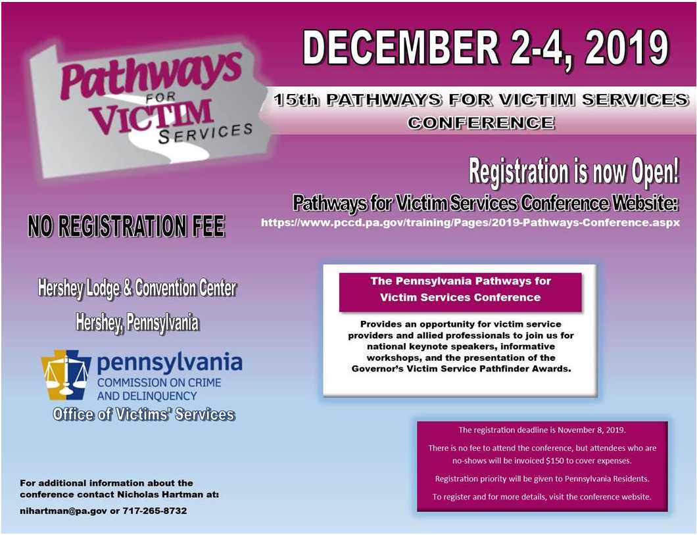
Return to top

If your program is offering new or extended services, or implementing new initiatives that you would like to highlight, please submit your news article to Jennifer Moore at jemoore@pa.gov.
The next OVS Newsletter will be published on Wednesday, November 6, 2019. If you would like any training events, fundraisers, or notable news published in this newsletter, please submit them to Jennifer Moore at jemoore@pa.gov by Wednesday, October 30, 2019.
You have signed up to receive the OVS Newsletter from the Office of Victims' Services. This newsletter will be sent to you on a biweekly basis via email. If your email address changes or you would like to be removed from the OVS Newsletter distribution list, please contact Jennifer Moore at (717) 265-8705 or via email at jemoore@pa.gov.
Return to top
Pennsylvania’s Office of Victims’ Services | 3101 North Front Street | Harrisburg, PA 17110 | (717) 783-0551
www.pccd.pa.gov
PA Crime Victims Website
www.pcv.pccd.pa.gov
Twitter: @PaCrimeComm.

