Charles Ramsey
Chairman
Michael Pennington
Executive Director

OVS Newsletter
October 9, 2019

In this Issue...
- Third Quarter RASA/VOJO Quarterly Reports Due by October 20th
- PCAR RFP for Adams County
- National Crime Victims’ Service Awards
- Continuing the Dialogue: Learning from the Past and Looking to the Future of Intimate Partner Violence & Sexual Violence Prevention
- National Sexual Violence Resource Center – Active Listening Terms Resource
- ‘We Must Keep Loving’: Trauma Lingers Two Years After Mass Shooting in Las Vegas
- Chanel Miller’s New Short Film Is a Moving Tribute to the Strength of Survivors
- New FBI Data: Violent Crime Still Falling
- FBI: Uniform Crime Reporting (UCR) - 2018 Crime in the United States
- Nearly Two Thousand Women Killed by Men in 2017, Report Urges Reauthorization of Violence Against Women Act
- Network of Victims Assistance (NOVA) Job Announcement: Pennsylvania Crisis Response Team Project Coordinator

Upcoming Trainings
- Victims Compensation Online Trainings
- New Course Available on Pennsylvania Victim Services Training (PVST)
- Taking Action: Assisting Victims of Financial Fraud - Webinar
- From Trauma to Healing – A Training and Discussion on Child Abuse, Child Sexual Violence, Risk Reduction, & Healing
- End Violence Against Women International Offering Archived Webinars 24/7
- The Hidden Crime of Human Trafficking in Rural Communities and the Health Care System & Community Response
- National Coalition Against Domestic Violence Webinar – DVAM is 365 Days Long: How to Raise Awareness of Domestic Violence During and Beyond October
- OVC TTAC Webinar – Domestic Violence High Risk Teams
- OVC TTAC Webinar – Courageous Spirit: The Effects of Historical Trauma on AI/AN Communities
- STOP Domestic Violence Trainings Across PA
- PDAI Victim Services Trainings

Conferences
- 2019 Pathways for Victim Services
- SafeNet Erie Twentieth Anniversary Conference
- Leave No Victim Behind 2019 Conference

Upcoming Events
  - WebEx Online Trainings Available
Compensation Related: Basic Compensation and much more!
Credits towards VOCA/RASA/VOJO training requirements are available for all sessions (unless indicated otherwise in the session description). To receive training credits: 1) you must be logged into the session and 2) the WebEx application must be on your computer for the entire duration of the session. As the OVS recognizes that emergencies may arise and you may not be able to attend the entire session, there is no prohibition against attending part of a session (although training credits will not be given in that instance).
  - Training/Networking Opportunities
  - Additional RASA/VOJO/VOCA Approved Training
Return to top

Third Quarter RASA/VOJO Quarterly Reports Due by October 20th
Reminder to all RASA and VOJO Programs – Third Quarter Program Reports Due October 20th
Quarterly Program Reports for the Third Quarter of the 2019-2020 RASA/VOJO Grants will be due by October 20, 2019.
(Note: Since October 20th is on a Sunday, please submit your reports in Egrants by Friday, October 18, 2019 to ensure they are not delinquent.)
Third Quarter Program Reports for RASA and VOJO grants should be submitted to cover the period from July 1 – September 30, 2019.
If you have any questions regarding your program reports, please contact Vicki McCloskey at Vmccloskey@pa.gov or (717) 265-8746 or Maria Katulis at mkatulis@pa.gov or (717) 265-8741.
Third Quarter Fiscal Reports for RASA and VOJO grants will also be due in Egrants by October 20, 2019. Please contact the fiscal staff person listed on your grant for any questions you may have. If you need technical assistance with Egrants, please contact the Egrants Support Line at (717) 787-5887.
Return to top

PCAR RFP for Adams County
The Pennsylvania Coalition Against Rape (PCAR) will be accepting Requests for Proposals (RFP) to provide services related to sexual harassment, abuse, and assault in Adams County, Pennsylvania. This competitive application is for January 1, 2020-June 30, 2020 with yearly renewals through Fiscal Year 2021-2022. The RFP is available on the PCAR website (www.pcar.org). All RFPs must be submitted electronically. Organizations wishing to apply will have until October 18, 2019 to submit an application to PCAR. The Director of Grants & Contracts, Lou Ann Williams, will serve as the point of contact for any questions. Ms. Williams can be contacted between 8:00 AM – 4:00 PM Monday through Friday at (800) 692-7445 ext. 118 or (717) 728-9740 Ext. 118 or by email at lwilliams@pcar.org.
Applicants must be incorporated under the Nonprofit Corporation Law of The Commonwealth of Pennsylvania and must have achieved and maintained a 501(c) (3) tax-exempt status. Priority will be given to applicants that have provided services related to sexual harassment, abuse, and assault for at least one (1) full year prior to the time of the proposal.
The subcontract will be awarded to the applicant which demonstrates an ability to provide the following services throughout Adams County: 24-hour hotline; accompaniment to medical facilities, police investigations, and court proceedings; crisis counseling; supportive counseling; individual advocacy; information and referral; systems advocacy; prevention education; public relations; and professional training. An explanation of these services can be found in the Application Instructions on www.pcar.org.
All services must be provided in accordance with applicable rules and regulations set forth by the Department of Human Services, and all services must be available to every member of the community, including people of all ages, races, creeds, gender identities, ethnicities, colors, national origins, marital statuses, sexual orientations, physical or mental abilities, cultures, language abilities, classes, economic statuses, education-levels, and HIV statuses. Applicants cannot refuse to provide services based on income. Services must be provided to Pennsylvania residents regardless of the county of residence.
The evaluation of applications will be conducted by PCAR’s Independent Review Committee (IRC). PCAR's IRC is composed of five (5) individuals, representing diverse interests, cultures, and backgrounds. The IRC will review all applications and rule upon their acceptability. The IRC will make recommendations about application content and may request revisions to a proposal. Additional information regarding the Competitive Application Process for Subcontracts is available on www.pcar.org. In conjunction with the recommendation of the Independent Review Committee, the Pennsylvania Coalition Against Rape has the right to reject any and all applications if the applicant(s) is determined not to be equipped to provide the required services.
Return to top

National Crime Victims’ Service Awards
The 2020 National Crime Victims’ Service Awards nomination period is now open. If you know a deserving individual, organization, team or program, submit a nomination by October 9, 2019.
Click here to read more.
Return to top

Continuing the Dialogue: Learning from the Past and Looking to the Future of Intimate Partner Violence & Sexual Violence Prevention
The Centers for Disease Control and Prevention’s (CDC) Division of Violence Prevention (DVP) focuses on primary prevention, which is preventing violence before it occurs. In the early 2000s, CDC reviewed theoretical frameworks for sexual violence prevention and sought input from external partners in the field, resulting in CDC’s publication, Sexual Violence Prevention: Beginning the Dialogue (2004). Originally intended to define and describe prevention concepts and strategies to support CDC’s Rape Prevention and Education (RPE) Program, this foundational document helped to launch a national conversation about moving upstream to prevent violence before it occurs.
Click here to read more.
Return to top

National Sexual Violence Resource Center – Active Listening Terms Resource
This handout provides definitions of key active listening terms used in the Listen Up! Active Listening as Advocacy online course and its companion handouts: Role Plays for Active Listening Reflection & Scenarios for Active Listening.
Click here to read more.
Return to top

‘We Must Keep Loving’: Trauma Lingers Two Years After Mass Shooting in Las Vegas
The aftermath of a mass shooting has become all too familiar: Funerals take place, obituaries are written, heroes are highlighted, hashtags are created, motives are questioned, guns and mental health are debated. There is often the painful breakdown of a parent who lost their child on the evening news, images of community members holding candles on the front page of newspapers, and soundbites of politicians calling for gun control on social media. A community's physical pain and mourning are exposed. Two years later, some survivors are not yet back to work. Some of those injured are waiting for their next surgery. And widows are raising children alone while trying to balance their healing.
Click here to read more.

Return to top

Chanel Miller’s New Short Film Is a Moving Tribute to the Strength of Survivors
Until a few weeks ago, Chanel Miller was known to the public as Emily Doe. A sexual assault survivor—whose powerful impact statement addressed to her assailant, Brock Turner, went viral—Miller chose not to speak out under her own name but instead to let her words stand on their own. That decision, Miller told the New York Times, "let me have a life in which this never happened," giving her time to still be Chanel and not "the nameless, faceless, half-naked body from this case."
Click here to read more.
Return to top

New FBI Data: Violent Crime Still Falling
FBI data released Monday suggests that the violent crime rate in the U.S. remains on a decades-long downward trend, falling by 3.9 percent in 2018. Overall, the violent crime rate has plunged by more than 50 percent since the highwater mark of the early 1990s. The rate for rape bucked this trend however, up slightly for 2018, and in each of the last six years.
Click here to read more.
Return to top

FBI: Uniform Crime Reporting (UCR) - 2018 Crime in the United States
Criminal Justice Information Services Division’s About Crime in the U.S. (CIUS) report for 2018 is now available.
Click here to read more.
Return to top

Nearly Two Thousand Women Killed by Men in 2017, Report Urges Reauthorization of Violence Against Women Act
A new study conducted by the Violence Policy Center (VPC) found that in 2017, 1,948 women were murdered by men. The study, entitled When Men Murder Women: An Analysis of 2017 Homicide Data, analyzed incidents involving one man murdering one woman. The study, which has been conducted annually, has shown an overall downward trend since 1996, but showed that since 2014 the rate has steadily increased and as of 2017, is up 19 percent.
Click here to read more.
Return to top

Network of Victims Assistance (NOVA) Job Announcement: Pennsylvania Crisis Response Team Project Coordinator
Pennsylvania Crisis Response Team Project Coordinator
As a project of Network of Victim Assistance, the Keystone Crisis Intervention Team (KCIT) is a Pennsylvania statewide crisis response team, providing trained teams of individuals to serve any community within the Commonwealth where a crime has taken place. KCIT is funded through the Pennsylvania Commission on Crime and Delinquency.
Since its first deployment in 2000, KCIT has provided crisis interventions to over 11,300 individuals. Types of crimes that KCIT teams have responded to include domestic violence homicides, school shootings, workplace shootings, bank robberies, terrorism and any other criminal incidents where there have been multiple victims or witnesses.
Additionally, statewide KCIT provides a 25-hour training for new team members, advanced training opportunities for experienced volunteers, simulation trainings, and specialty trainings for the community such as responses to trauma, resilience and coping, and death notification.
Position Description:
This position is responsible for coordinating deployments; supporting volunteer team members; supervising full and part time staff who provide trainings; serves as the project liaison to the statewide advisory committee; attends various local and state meetings as project representative; grant writing; grant reporting; and planning the biennial statewide conference.
A flexible schedule is required as the position does require some daytime and overnight travel to present at statewide and national conferences, attend advisory meetings in Harrisburg quarterly, potential deployment related travel, and some occasional travel to Western Pennsylvania for project management related tasks.
Social work, management, human services or related Master’s degree preferred (Bachelor’s degree with relevant experience will be considered). Supervision, volunteer coordinator, and project management experience.
Competitive salary and excellent benefits. Applicants must send a cover letter with salary requirements in addition to their resume. AA/EOE. Submit to Debgh@novabucks.org
Return to top

Victims Compensation Online Trainings
October 9, 2019
Stolen Benefit Cash Expenses Clinic 10:00a.m – 11:00 a.m.
Loss of Earnings Clinic 11:30 a.m. – 12:30 p.m.
October 16, 2019
Loss of Support Clinic 10:00 a.m. – 11:00 a.m.
October 22, 2019
Relocation Expenses Clinic 9:30 a.m. – 10:30 a.m.
Counseling Expenses Clinic 11:00 a.m. – 12:00 p.m.
October 24, 2019
Restitution Basics 10:00a.m. – 11:00a.m.
October 29, 2019
Funeral & Burial Expenses Clinic 9:30 a.m. – 10:30 a.m.
Crime Scene Cleanup Expenses Clinic 11:00 a.m. – 12:00 p.m.
November 12, 2019
Basic Compensation 10:00 a.m. – 12:00 p.m.
Click here to register.
All trainings count towards 1 hour of the required RASA/VOCA/VOJO training hours, except for Basic Compensation, which counts towards 2 training hours, and DAVE training, which counts towards 2.15 training hours.
Return to top

New Course Available on Pennsylvania Victim Services Training (PVST)
A new course, “Economic Justice for Victims of Crime” has been released on the PVST. The goal of this online module is to give learners guidance in holistically addressing the economic issues faced by victims of crime. The course discusses a variety of issues, from direct monetary loss to indirect losses resulting from crime, such as the inability to afford the essentials of daily life and compromised credit ratings. Advocates are provided with practical resources and strategies to help with meeting the economic issues that result from and/or arise simultaneously from criminal victimization.
Click here to register.

Return to top

Taking Action: Assisting Victims of Financial Fraud - Webinar
The National Identity Theft Victims Assistance Network (NITVAN) and the National Center for Victims of Crime invite you to participate in a webinar on the intersection between identity theft and family violence on October 9, 2019 at 1:00 p.m. EST. This webinar will be presented by the Texas Coalition on Coerced Debt, which is a team of Texas-based attorneys, advocates, policymakers, financial professionals, and law enforcement that works to promote identity theft protections for survivors of family violence.
During this webinar, coalition members Carla Sanchez-Adams and Stephanie James of Texas Rio Grande Legal Aid, will share with attendees how to identify the unique type of identity theft that happens in the context of family violence. They will also discuss the various available avenues for service providers when helping victims of family violence cope with identity theft.
Click here to register.
Return to top

From Trauma to Healing – A Training and Discussion on Child Abuse, Child Sexual Violence, Risk Reduction, & Healing
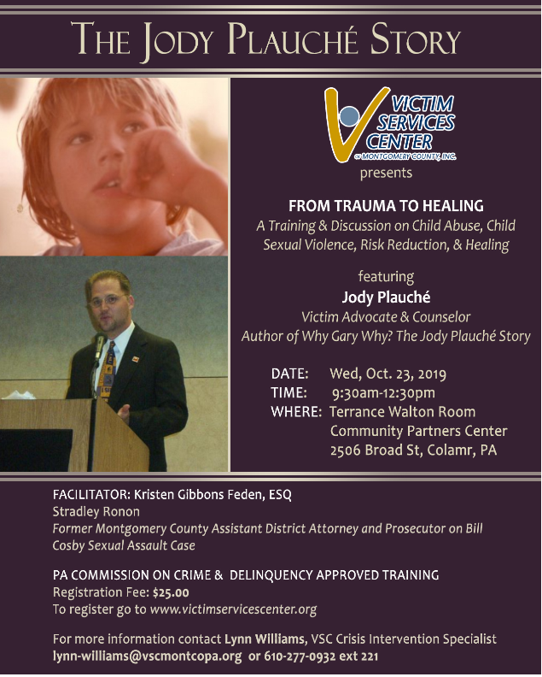
Victim Services Center of Montgomery County, Inc. is holding a training and discussion on child abuse, child sexual violence prevention, risk reduction and healing featuring Jody Plauche, a former employee of Victim Services Center who returns to share his story. This training is approved by Pennsylvania Commission on Crime & Delinquency (PCCD) for three (3) training hours. The training and discussion session will offer skill building insights and information for professionals and community members concerned about safety and wellbeing of children.
The training will be on Wednesday, October 23, 2019 9:30 a.m. - 12:30 p.m. at the Community Health Foundation, 2506 Broad Street, Colmar, PA in the Terrance Walton Room.
Click here to register.
Return to top

End Violence Against Women International Offering Archived Webinars 24/7
Webinars are one of the many tools EVAWI offers to help law enforcement professionals and others improve the criminal justice response to sexual assault. All webinars are free. There are currently over 35 webinars available in the archive addressing topics such as:
- Trauma Informed Interviewing - Turning Understanding into Outcomes.
- A Dangerous Defense: "Blackout" in Alcohol Facilitated, Non-Stranger Sexual Assault Cases.
- Adult Sex Offenders - What You Need to Know.
- Reading Between the Lines: Case File Review for SARTs.
These webinars offer the same experience as the live version, with the added benefit of being available 24/7/365.
Click here to read more.
Return to top

The Hidden Crime of Human Trafficking in Rural Communities and the Health Care System & Community Response
On October 29, 2019, The Pennsylvania Office of Rural Health, in partnership with the Region III Office of the Health Resources and Services Administration, U.S. Department of Health and Human Services, the Eastcentral and Northeast Pennsylvania Area Health Education Center, and the Pennsylvania Coalition Against Rape, is offering this one-day continuing education and outreach event to continue a rural human trafficking collaborative with an emphasis on rural prevention, treatment, and community collaboration.
Join us to hear stories from victims of human trafficking and learn about the impact of this crisis in Pennsylvania, the role of law enforcement, and how health care providers are trained to identify victims of human trafficking and how community partnerships address this pervasive issue.
Click here to register.
Return to top

National Coalition Against Domestic Violence Webinar – DVAM is 365 Days Long: How to Raise Awareness of Domestic Violence During and Beyond October
Join the National Coalition Against Domestic Violence (NCADV) and the National Resource Center for Domestic Violence (NRCDV) for a FREE webinar. You’ll learn more about these organizations’ Domestic Violence Awareness Month campaigns, how to utilize available tools and resources to make these campaigns relevant to your audience and how to integrate DVAM into your policy and educational work to make DVAM’s impact last beyond October.
For additional information and to register, please click here.
Return to top

OVC TTAC Webinar – Domestic Violence High Risk Teams
The Office for Victims of Crime Training & Technical Assistance Center (OVC TTAC) is offering an upcoming webinar.
The Domestic Violence High Risk Team (DVHRT) Model was born from one community’s tragedy and has gone on to national recognition and replication as a leading strategy for intimate partner homicide prevention. This presentation will provide a comprehensive understanding of the DVHRT Model, with an overview of the research at its foundation, and include a discussion on the function and structure of key partners in this multidisciplinary approach. Participants will learn how team members work together to identify high-risk cases and mobilize risk management strategies.
Click here to register.
Return to top

OVC TTAC Webinar – Courageous Spirit: The Effects of Historical Trauma on AI/AN Communities
The Office for Victims of Crime Training & Technical Assistance Center (OVC TTAC) is offering an upcoming webinar.
This session will identify the historical and traditional ways that domestic and sexual violence were addressed in American Indian and Alaska Native (AI/AN) communities prior to colonization and how historical experiences persist to have residual trauma in the community. Recommendations will be provided to improve advocacy for native communities that have been affected by domestic and sexual violence.
Click here to register.
Return to top

STOP Domestic Violence Trainings Across PA
The Office of Victim Advocate has partnered with the Finding Jenn’s Voice film and curriculum to deliver a FREE statewide training like none other! OVA will be traveling across the state (10 locations in 2 years) to bring to you a training focused on:
Recognizing the various aspects of domestic violence.
The protocols we use to combat this epidemic.
The tools you need for effective supervision of an offender.
Access to services for victims.
Dates, locations and additional info will continue to be announced here. The next training will be in Williamsport on October 29, 2019. This curriculum is certified by MPOETC to provide 3 CEUs for municipal police officers as well as 6 hours of PCCD Annual Training. If you work in state/county probation, law enforcement, victim services, the district attorney or district justice office – this training is for you! Register here. Questions may be directed to Renee Bressler at rebressler@pa.gov.
Return to top

PDAI Victim Services Trainings

Harrisburg Foundational Academy
Date: October 9-11, 2019
Time: 9:00AM – 5:00PM
Location: The Best Western Premier/Central Hotel
Spaces are now full for this event.

Human Trafficking
Date: November 6, 2019
Time: 1:00PM – 5:00PM
Location: King of Prussia

Registration opens at www.pdaa.org under the PDAI’s Training Calendar. Contact the Training Consultant, Amy Smulktis at AJS@restitutionconsulting.com, for more details or if interested in a scholarship. Trainings qualify for PCCD-approved training hours.
To receive the quarterly Restitution & Victim/Witness Training Newsletter which includes important updates regarding Foundational Academy, Topical Trainings, and restitution, please email Amy Smulktis.
Return to top

2019 Pathways for Victim Services
The Pennsylvania Commission on Crime and Delinquency’s Office of Victims’ Services is very excited about the upcoming Pathways Conference and looks forward to seeing you there. The conference will be held at the Hershey Lodge on December 2nd – December 4th, 2019.
Registration is now open! Click here to register.
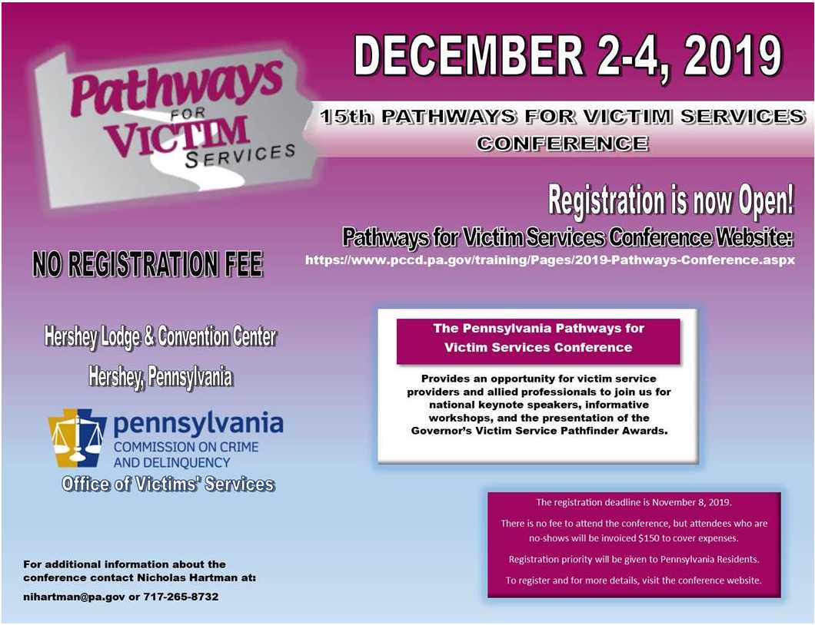
Return to top

SafeNet Erie Twentieth Anniversary Conference
Mark your calendars for SafeNet’s 20th annual conference, Intimate Partner Violence: The Silent Secret. The goal of this conference is to raise awareness of the impact that intimate partner violence (IPV) has on our community, while promoting action to improve responses to this social issue. In 2019, the conference will also focus on the issue of human trafficking and explain its correlation with IPV.
Click here to register.
Return to top

Leave No Victim Behind 2019 Conference
The University of Oregon Police Department and the California Victim Compensation Board are pleased to announce the Leave No Victim Behind IV National Training Conference for 2019. The conference will take place October 21–23, 2019, at the Conference Center of Las Vegas. The Leave No Victim Behind conference series will continue its focus on best practices for responding to mass violence and the unique partnerships between law enforcement and victim services to assist victims of crime. This year’s conference theme is Long-Term Recovery of Communities Following Mass Violence Incidents. The conference dates follow the second anniversary of the Route 91 Harvest Festival shooting in Las Vegas on October 1, 2017. Participants will hear from responders and victims of the Harvest Festival shooting regarding their recovery process over the last two years.
For conference registration, please click here.
To check the conference website for updates, click here.
Return to top

If your program is offering new or extended services, or implementing new initiatives that you would like to highlight, please submit your news article to Jennifer Moore at jemoore@pa.gov.
The next OVS Newsletter will be published on Wednesday, October 23, 2019. If you would like any training events, fundraisers, or notable news published in this newsletter, please submit them to Jennifer Moore at jemoore@pa.gov by Wednesday, October 16, 2019.
You have signed up to receive the OVS Newsletter from the Office of Victims' Services. This newsletter will be sent to you on a biweekly basis via email. If your email address changes or you would like to be removed from the OVS Newsletter distribution list, please contact Jennifer Moore at (717) 265-8705 or via email at jemoore@pa.gov.
Return to top
Pennsylvania’s Office of Victims’ Services | 3101 North Front Street | Harrisburg, PA 17110 | (717) 783-0551
www.pccd.pa.gov
PA Crime Victims Website
www.pcv.pccd.pa.gov
Twitter: @PaCrimeComm.

