Charles Ramsey
Chairman
Michael Pennington
Executive Director

OVS Newsletter
September 25, 2019

In this Issue...
- VCAP Claim Form Changes
- PCAR RFP for Adams County
- She’s My Sister: Anti-Human Trafficking 5K Walk/Run
- Gallup Poll Shows That Nearly Half in U.S. Fear Being the Victim of a Mass Shooting
- Research Report: Identity Theft and Fraud Victimization
- Center for Victim Research - Spotlight
- National Crime Victims’ Service Awards
- One in Sixteen U.S. Women Say Their First Sexual Intercourse was Rape
- Understanding and Working with Adult Protective Services (APS)

Upcoming Trainings
- Victims Compensation Online Trainings
- The Hidden Crime of Human Trafficking in Rural Communities and the Health Care System & Community Response
- National Coalition Against Domestic Violence Webinar – DVAM is 365 Days Long: How to Raise Awareness of Domestic Violence During and Beyond October
- OVC TTAC Webinar – Domestic Violence High Risk Teams
- STOP Domestic Violence Trainings Across PA
- PDAI Victim Services Trainings

Conferences
- 2019 Pathways for Victim Services
- SafeNet Erie Twentieth Anniversary Conference
- Leave No Victim Behind 2019 Conference

Upcoming Events
  - WebEx Online Trainings Available
Compensation Related: Basic Compensation and much more!
Credits towards VOCA/RASA/VOJO training requirements are available for all sessions (unless indicated otherwise in the session description). To receive training credits: 1) you must be logged into the session and 2) the WebEx application must be on your computer for the entire duration of the session. As the OVS recognizes that emergencies may arise and you may not be able to attend the entire session, there is no prohibition against attending part of a session (although training credits will not be given in that instance).
  - Training/Networking Opportunities
  - Additional RASA/VOJO/VOCA Approved Training
Return to top

VCAP Claim Form Changes
The Victim Compensation Program is beginning the process of reviewing and making changes to the paper claim form. If there are any changes you would like to see made to the paper claim forms, please email your suggestions to Stacie Brendlinger at sbrendling@pa.gov by October 4, 2019.
Return to top

PCAR RFP for Adams County
The Pennsylvania Coalition Against Rape (PCAR) will be accepting Requests for Proposals (RFP) to provide services related to sexual harassment, abuse, and assault in Adams County, Pennsylvania. This competitive application is for January 1, 2020-June 30, 2020 with yearly renewals through Fiscal Year 2021-2022. The RFP will be made available September 16, 2019 on the PCAR website (www.pcar.org). All RFPs must be submitted electronically. Organizations wishing to apply will have until October 18, 2019 to submit an application to PCAR. The Director of Grants & Contracts, Lou Ann Williams, will serve as the point of contact for any questions. Ms. Williams can be contacted between 8:00 AM – 4:00 PM Monday through Friday at (800) 692-7445 ext. 118 or (717) 728-9740 Ext. 118 or by email at lwilliams@pcar.org.
Applicants must be incorporated under the Nonprofit Corporation Law of The Commonwealth of Pennsylvania and must have achieved and maintained a 501(c) (3) tax-exempt status. Priority will be given to applicants that have provided services related to sexual harassment, abuse, and assault for at least one (1) full year prior to the time of the proposal.
The subcontract will be awarded to the applicant which demonstrates an ability to provide the following services throughout Adams County: 24-hour hotline; accompaniment to medical facilities, police investigations, and court proceedings; crisis counseling; supportive counseling; individual advocacy; information and referral; systems advocacy; prevention education; public relations; and professional training. An explanation of these services can be found in the Application Instructions on www.pcar.org.
All services must be provided in accordance with applicable rules and regulations set forth by the Department of Human Services, and all services must be available to every member of the community, including people of all ages, races, creeds, gender identities, ethnicities, colors, national origins, marital statuses, sexual orientations, physical or mental abilities, cultures, language abilities, classes, economic statuses, education-levels, and HIV statuses. Applicants cannot refuse to provide services based on income. Services must be provided to Pennsylvania residents regardless of the county of residence.
The evaluation of applications will be conducted by PCAR’s Independent Review Committee (IRC). PCAR's IRC is composed of five (5) individuals, representing diverse interests, cultures, and backgrounds. The IRC will review all applications and rule upon their acceptability. The IRC will make recommendations about application content and may request revisions to a proposal. Additional information regarding the Competitive Application Process for Subcontracts is available on www.pcar.org. In conjunction with the recommendation of the Independent Review Committee, the Pennsylvania Coalition Against Rape has the right to reject any and all applications if the applicant(s) is determined not to be equipped to provide the required services.
Return to top

She’s My Sister: Anti-Human Trafficking 5K Walk/Run
The 5th Annual Anti-Human Trafficking 5K Walk/Run will be held on Saturday, October 5, 2019 in Fairmount Park, Philadelphia. Proceeds from the Walk/Run will be utilized to provide the necessary funding for the establishment of a safe trafficking-trauma informed long term therapeutic group home and restoration program for youth.
This Salvation Army Program will be utilized by the young women victims within our juvenile court system who are 18-21 years old and aging out of the children and youth system who need this awesome resource to assist them in moving from victims to survivors.
Click here for more information and to register.
Return to top

Gallup Poll Shows That Nearly Half in U.S. Fear Being the Victim of a Mass Shooting
In the wake of two August mass shootings that claimed the lives of 31 people in one weekend, Americans are more worried about themselves or a family member being the victim of a mass shooting.
Click here to read more.
Return to top

Research Report: Identity Theft and Fraud Victimization
Millions of people in the United States fall victim to identity theft, identity fraud, and other types of fraud each year, knowingly or unknowingly. This report reviews identity theft and fraud victims from research-and-practice-based evidence.
Click here to read more.
Return to top

Center for Victim Research - Spotlight
The Center for Victim Research highlights National Hispanic Heritage Month, National Campus Safety Awareness Month, among other awareness features in their Spotlight/Fall 2019.
Click here to read more.
Return to top

National Crime Victims’ Service Awards
The 2020 National Crime Victims’ Service Awards nomination period is now open. If you know a deserving individual, organization, team or program, submit a nomination by October 9, 2019.
Click here to read more.
Return to top

One in Sixteen U.S. Women Say Their First Sexual Intercourse was Rape
A staggering one in 16 women said they were raped by force or coercion the first time they had sexual intercourse, according to a new study of government survey data.
Survivors reported higher rates of unwanted first pregnancy, abortion and an array of other physical and mental health problems, study authors wrote in an analysis published Monday in the Journal of the American Medical Association.
Click here to read more.
Return to top

Understanding and Working with Adult Protective Services (APS)
This is the first of a three-part resource developed by the National Adult Protective Services Association in collaboration with the National Center on Elder Abuse. The goal is to provide information for understanding and collaborating with Adult Protective Services (APS) in order to benefit older adults and adults with disabilities who are subjected to abuse, neglect, or exploitation (ANE).
Click here to read more.
Return to top

Victims Compensation Online Trainings
October 1, 2019
Basic Compensation 9:30a.m. – 11:30 a.m.
October 9, 2019
Stolen Benefit Cash Expenses Clinic 10:00a.m – 11:00 a.m.
Loss of Earnings Clinic 11:30 a.m. – 12:30 p.m.
October 16, 2019
Loss of Support Clinic 10:00 a.m. – 11:00 a.m.
October 22, 2019
Relocation Expenses Clinic 9:30 a.m. – 10:30 a.m.
Counseling Expenses Clinic 11:00 a.m. – 12:00 p.m.
October 24, 2019
Restitution Basics 10:00a.m. – 11:00a.m.
October 29, 2019
Funeral & Burial Expenses Clinic 9:30 a.m. – 10:30 a.m.
Crime Scene Cleanup Expenses Clinic 11:00 a.m. – 12:00 p.m.
November 12, 2019
Basic Compensation 10:00 a.m. – 12:00 p.m.
Click here to register.
All trainings count towards 1 hour of the required RASA/VOCA/VOJO training hours, except for Basic Compensation, which counts towards 2 training hours, and DAVE training, which counts towards 2.15 training hours.
Return to top

The Hidden Crime of Human Trafficking in Rural Communities and the Health Care System & Community Response
On October 29, 2019, The Pennsylvania Office of Rural Health, in partnership with the Region III Office of the Health Resources and Services Administration, U.S. Department of Health and Human Services, the Eastcentral and Northeast Pennsylvania Area Health Education Center, and the Pennsylvania Coalition Against Rape, is offering this one-day continuing education and outreach event to continue a rural human trafficking collaborative with an emphasis on rural prevention, treatment, and community collaboration.
Join us to hear stories from victims of human trafficking and learn about the impact of this crisis in Pennsylvania, the role of law enforcement, and how health care providers are trained to identify victims of human trafficking and how community partnerships address this pervasive issue.
Click here to register.
Return to top

National Coalition Against Domestic Violence Webinar – DVAM is 365 Days Long: How to Raise Awareness of Domestic Violence During and Beyond October
Join the National Coalition Against Domestic Violence (NCADV) and the National Resource Center for Domestic Violence (NRCDV) for a FREE webinar. You’ll learn more about these organizations’ Domestic Violence Awareness Month campaigns, how to utilize available tools and resources to make these campaigns relevant to your audience and how to integrate DVAM into your policy and educational work to make DVAM’s impact last beyond October.
For additional information and to register, please click here.
Return to top

OVC TTAC Webinar – Domestic Violence High Risk Teams
The Office for Victims of Crime Training & Technical Assistance Center (OVC TTAC) is offering an upcoming webinar.
The Domestic Violence High Risk Team (DVHRT) Model was born from one community’s tragedy and has gone on to national recognition and replication as a leading strategy for intimate partner homicide prevention. This presentation will provide a comprehensive understanding of the DVHRT Model, with an overview of the research at its foundation, and include a discussion on the function and structure of key partners in this multidisciplinary approach. Participants will learn how team members work together to identify high-risk cases and mobilize risk management strategies.
Click here to register.
Return to top

STOP Domestic Violence Trainings Across PA
The Office of Victim Advocate has partnered with the Finding Jenn’s Voice film and curriculum to deliver a FREE statewide training like none other! OVA will be traveling across the state (10 locations in 2 years) to bring to you a training focused on:
Recognizing the various aspects of domestic violence.
The protocols we use to combat this epidemic.
The tools you need for effective supervision of an offender.
Access to services for victims.
Dates, locations and additional info will continue to be announced here. The next training will be in the Williamsport area, location TBA. This curriculum is certified by MPOETC to provide 3 CEUs for municipal police officers as well as 6 hours of PCCD Annual Training. If you work in state/county probation, law enforcement, victim services, the district attorney or district justice office – this training is for you! Register here. Questions may be directed to Renee Bressler at rebressler@pa.gov.
Return to top

PDAI Victim Services Trainings

Harrisburg Foundational Academy
Date: October 9-11, 2019
Time: 9:00AM – 5:00PM
Location: The Best Western Premier/Central Hotel
Spaces are now full for this event.

Human Trafficking
Date: November 6, 2019
Time: 1:00PM – 5:00PM
Location: King of Prussia

Registration opens at www.pdaa.org under the PDAI’s Training Calendar. Contact the Training Consultant, Amy Smulktis at AJS@restitutionconsulting.com, for more details or if interested in a scholarship. Trainings qualify for PCCD-approved training hours.
To receive the quarterly Restitution & Victim/Witness Training Newsletter which includes important updates regarding Foundational Academy, Topical Trainings, and restitution, please email Amy Smulktis.
Return to top

2019 Pathways for Victim Services
The Pennsylvania Commission on Crime and Delinquency’s Office of Victims’ Services is very excited about the upcoming Pathways Conference, and looks forward to seeing you there. The conference will be held at the Hershey Lodge on December 2nd – December 4th, 2019.
Registration is now open! Click here to register.
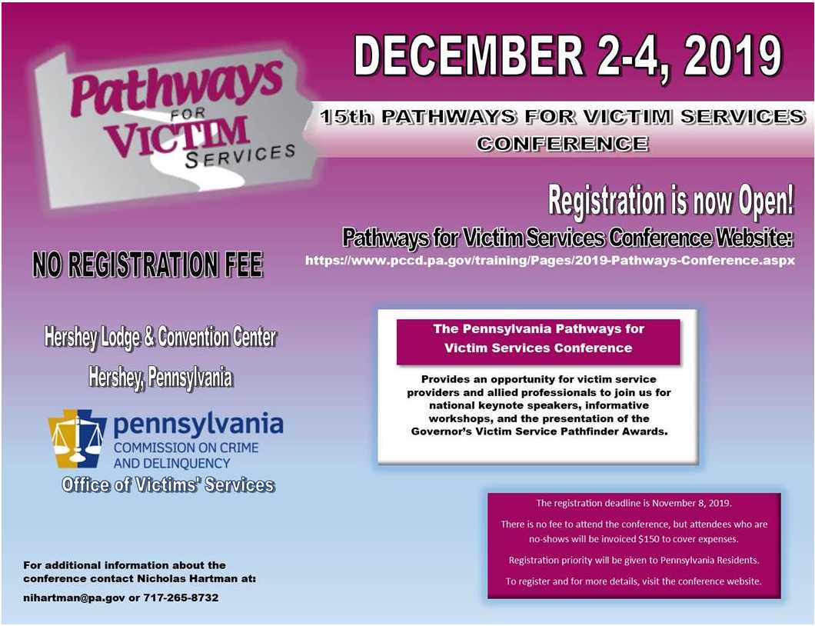
Return to top

SafeNet Erie Twentieth Anniversary Conference
Mark your calendars for SafeNet’s 20th annual conference, Intimate Partner Violence: The Silent Secret. The goal of this conference is to raise awareness of the impact that intimate partner violence (IPV) has on our community, while promoting action to improve responses to this social issue. In 2019, the conference will also focus on the issue of human trafficking and explain its correlation with IPV.
Click here to register.
Return to top

Leave No Victim Behind 2019 Conference
The University of Oregon Police Department and the California Victim Compensation Board are pleased to announce the Leave No Victim Behind IV National Training Conference for 2019. The conference will take place October 21–23, 2019, at the Conference Center of Las Vegas. The Leave No Victim Behind conference series will continue its focus on best practices for responding to mass violence and the unique partnerships between law enforcement and victim services to assist victims of crime. This year’s conference theme is Long-Term Recovery of Communities Following Mass Violence Incidents. The conference dates follow the second anniversary of the Route 91 Harvest Festival shooting in Las Vegas on October 1, 2017. Participants will hear from responders and victims of the Harvest Festival shooting regarding their recovery process over the last two years.
For conference registration, please click here.
To check the conference website for updates, click here.
Return to top

If your program is offering new or extended services, or implementing new initiatives that you would like to highlight, please submit your news article to Jennifer Moore at jemoore@pa.gov.
The next OVS Newsletter will be published on Wednesday, October 9, 2019. If you would like any training events, fundraisers, or notable news published in this newsletter, please submit them to Jennifer Moore at jemoore@pa.gov by Wednesday, October 2, 2019.
You have signed up to receive the OVS Newsletter from the Office of Victims' Services. This newsletter will be sent to you on a biweekly basis via email. If your email address changes or you would like to be removed from the OVS Newsletter distribution list, please contact Jennifer Moore at (717) 265-8705 or via email at jemoore@pa.gov.
Return to top
Pennsylvania’s Office of Victims’ Services | 3101 North Front Street | Harrisburg, PA 17110 | (717) 783-0551
www.pccd.pa.gov
PA Crime Victims Website
www.pcv.pccd.pa.gov
Twitter: @PaCrimeComm.

