Charles Ramsey
Chairman
Michael Pennington
Executive Director

OVS Newsletter
November 6, 2019

In this Issue...
- Victims Compensation Online Trainings
- Resources & Training Materials – Aequitas
- How to Provide Expert Training for Law Enforcement in Sexual Assault Response and Investigation
- “Start by Believing” Day is April 1st – End Violence Against Women International (EVAWI) are Collecting Personal Stories from Sexual Assault Survivors.
- Ensuring Access for People with Disabilities and Deaf People
- Newsletters For Timely Victim Research
- Understanding and Working With Adult Protective Services (APS)
- Preventing Intimate Partner Violence Across the Lifespan
- PDAI PA SAVIN CONSULTANT

Upcoming Trainings
- PA Immigration Resource Center Webinar – Bilingual Staff’s Role in Language Access
- OVC TTAC Webinar – Courageous Spirit: The Effects of Historical Trauma on AI/AN Communities
- The North Eastern Pennsylvania (NEPA) Task Force Against Human Trafficking – Regional Training
- PA Immigration Resource Center Webinar – Hiring, Retaining and Supporting Bilingual Staff at Your Organization
- The Criminalization of Trafficking Victims: Beyond Prostitution (Webinar)
- PDAI Victim Services Trainings

Conferences
- 2019 Pathways for Victim Services

Upcoming Events
  - WebEx Online Trainings Available
Compensation Related: Basic Compensation and much more!
Credits towards VOCA/RASA/VOJO training requirements are available for all sessions (unless indicated otherwise in the session description). To receive training credits: 1) you must be logged into the session and 2) the WebEx application must be on your computer for the entire duration of the session. As the OVS recognizes that emergencies may arise and you may not be able to attend the entire session, there is no prohibition against attending part of a session (although training credits will not be given in that instance).
  - Training/Networking Opportunities
  - Additional RASA/VOJO/VOCA Approved Training
Return to top

Victims Compensation Online Trainings
November 12, 2019
Basic Compensation 10:00 a.m. – 12:00 p.m.
Click here to register for the above trainings.

November 19, 2019
DAVE Webex Training 1:00 p.m. – 3:15 p.m.
Click here to register for this training.

All trainings count towards 1 hour of the required RASA/VOCA/VOJO training hours, except for Basic Compensation, which counts towards 2 training hours, and DAVE training, which counts towards 2.15 training hours.
Return to top

Resources & Training Materials – Aequitas
Aequitas develops and publishes a wide range of resources and training materials on topics related to the investigation and prosecution of gender-based violence and human trafficking.
Click here to read more.
Return to top

How to Provide Expert Training for Law Enforcement in Sexual Assault Response and Investigation
End Violence Against Women International (EVAWI) often receives requests for help identifying expert speakers to present at a local, regional, or statewide training event for law enforcement. EVAWI is unable to provide this type of in-person training on a local level. However, they will provide resources you need to host a successful training event including suggestions on how to find experts in the field to enhance your training.
Click here to read more.
Return to top

“Start by Believing” Day is April 1st – End Violence Against Women International (EVAWI) are Collecting Personal Stories from Sexual Assault Survivors.
When sexual assault victims turn to us, we know that every response matters. The responses of friends and family members matter. The responses of police officers, nurses, and advocates matter. Simply put, every response to a sexual assault victim matters, because it can have a powerful impact on their healing process and pursuit of justice.
With this in mind, the theme for our 5th Annual Start by Believing Day is: Every Response Matters – Share Yours!
Click here to read more.
Return to top

Ensuring Access for People with Disabilities and Deaf People
The Vera Institute publishes great information about improving access and services to people with disabilities and deaf people.
Click here to learn more.
Return to top

Newsletters For Timely Victim Research
Newsletters can deliver timely articles from a broad range of sources and provide unique commentary on issues relevant to victim services professionals. Newsletters can help you stay in the loop on the latest studies and research trends and on the evolving conversations and thoughts of your colleagues. Click here to sign up for newsletters that frequently include victim research, including resources related to child abuse, elder abuse, sexual violence, gender-based violence, intimate partner violence, criminal justice, community engagement, and social and health services.
Return to top

Understanding and Working With Adult Protective Services (APS)
Victimization of older adults and adults with disabilities is a public health, justice, social, and community problem that cannot be resolved by one individual or agency acting alone. Adult Protective Services must collaborate with community members, and other professionals, and organizations to effectively serve people who have experienced maltreatment. Part I of this series, provided in an earlier OVS newsletter, covered APS program functions, responsibilities, policies, practices, clients served, and constraints. The goals of Part II are to: 1) promote understanding of APS abuse reporting, intake, screening, triaging, and investigation processes; and 2) promote community and professional collaboration with APS during abuse reporting and investigation.
Click here for Part II.
Return to top

Preventing Intimate Partner Violence Across the Lifespan
The CDC’s Preventing Intimate Partner Violence technical package offers evidence-based strategies across each level of the social ecology for preventing violence at every age. This technical package is a compilation of a core set of strategies that are deemed likely to reduce the overall incidence of intimate partner violence based on the best available evidence. Organized by three components, strategy, approach and evidence, this collection was designed to help communities make informed decisions and prioritize their efforts. Access the technical package here.
Return to top

PDAI PA SAVIN CONSULTANT
The Pennsylvania District Attorneys Institute (PDAI) is seeking a consultant to provide oversight to the Pennsylvania Statewide Automated Victim Information and Notification (PA SAVIN) program. PA SAVIN provides crime victims and other interested individuals with free, confidential notification regarding an offender’s release, transfer or escape. This consultant will work exclusively on the county jail-related portion of PA SAVIN. The contract period will be January 1, 2020-December 31, 2020. The consulting fee is negotiable based upon experience and capabilities. This is an ongoing project anticipated to require consultant services beyond 2020.
The following is a description of the consultant’s responsibilities:
1. Consultant will perform in the system administrator role and be responsible for the following:
a) Track any county PA SAVIN outages and work with the PA SAVIN vendor’s operations center for resolution.
b) Troubleshoot any problems that may arise regarding the PA SAVIN vendor with respect to PA SAVIN in any county where PA SAVIN is currently available.
c) Assign security and access roles to PA SAVIN users.
d) Ensure the PA SAVIN vendor abides by the performance requirements of the contract with Pennsylvania to provide PA SAVIN services.
e) Inform, evaluate, and assist victim service programs when their local PA SAVIN is disabled and subsequently enabled.
f) Independently make decisions and judgments when responding to a PA SAVIN emergency in a county, including how to respond to situations when a mass number of notifications are being sent incorrectly and PA SAVIN not sending notifications to a victim when offender has been released.
g) Collaborate with other government agencies such as county prisons, Prison Warden Associations, Office of the Victim Advocate, victim service agencies, PDAI, and the public to facilitate the PA SAVIN awareness initiatives.
h) Analyze and evaluate PA SAVIN concerns and correspondence from victim service providers and county prisons and subsequently identify possible resolutions.
i) Provide expert advice, direction, and assistance to the county prison staff in the identification of unused or missed codes of their jail management system.
j) Facilitate collaboration and communication between county prison staff and the PA SAVIN vendor’s staff to utilize identical codes for mapping of correct offender movement and victim notification.
k) Develop and update training materials for various audiences such as victim advocates, county prison staff and law enforcement.
l) Coordinate bi-weekly status conference calls with the PA SAVIN vendor to facilitate communication on any outstanding issues and receive updates on workable solutions to problems. The frequency of the calls may be increased based upon operational requirements.
m) Provide PA SAVIN-related technology training to county jails, county victim service personnel, and law enforcement.
n) Provide tools that will assist counties with public awareness campaigns regarding PA SAVIN in their community and assist counties in coordinating media announcements for local agencies regarding PA SAVIN.
o) Assist in the design and implementation of any future updates or improvements to PA SAVIN.
p) Provide changes and updates to the PA SAVIN Collaboration website.
q) Produce an overall project report for PA SAVIN on an annual basis that measures specific results, including input from participating victims and agencies. This will require maintaining statistical information regarding the usage and performance of PA SAVIN and translating data into an easily understandable format.
r) Provide required quarterly reports and data via PCCD E-grants system.
s) Update, and confer with, PDAI Director and PCCD on PA SAVIN operations as appropriate.
If interested please submit a cover letter and resume by Tuesday, November 19, 2019 to:
Lindsay Vaughan
Executive Director
Pennsylvania District Attorneys Association
2929 North Front Street
Harrisburg, PA 17110
or lvaughan@pdaa.org
Return to top

PA Immigration Resource Center Webinar – Bilingual Staff’s Role in Language Access

On Wednesday, November 13, 2019, PIRC is offering a webinar geared toward bilingual domestic and sexual violence victim advocates and volunteers. Participants will explore the role of bilingual staff in your organization’s language access plan, identify and distinguish the roles of bilingual staff and of interpreters, and examine strategies for advocating towards improved language access within and outside one’s organization and for upholding professional boundaries of bilingual advocates, staff and volunteers.

Presenter’s Bio: Ana I. DeCarolis is a Project Coordinator with Casa de Esperanza – National Latin@ Network and Language Access Liaison for the National Resource Center on Reaching Crime Victims (NRC). Ana has six years of experience doing community outreach and education around language access rights, serving as a language access advocate on behalf of DV survivors with Limited English Proficiency (LEP), and supporting local city departments in enhancing their language access policies and practices. Ana holds a B.A. in Educational Sciences from the University of Buenos Aires, Argentina, and an M.A. in Education from San Francisco State University.
Click here to register.
Return to top

OVC TTAC Webinar – Courageous Spirit: The Effects of Historical Trauma on AI/AN Communities

The Office for Victims of Crime Training & Technical Assistance Center (OVC TTAC) is offering an upcoming webinar. This session will identify the historical and traditional ways that domestic and sexual violence were addressed in American Indian and Alaska Native (AI/AN) communities prior to colonization and how historical experiences persist to have residual trauma in the community. Recommendations will be provided to improve advocacy for native communities that have been affected by domestic and sexual violence.

Click here to register.
Return to top

The North Eastern Pennsylvania (NEPA) Task Force Against Human Trafficking – Regional Training
The North Eastern Pennsylvania (NEPA) Task Force Against Human Trafficking, in coordination with the Women’s Resource Center of Lackawanna and Susquehanna Counties, are co-hosting a no-cost educational presentation on the topic of human trafficking on Wednesday, November 20, 2019 from 9:00 a.m. until noon. This regional training will be held at the IHM/Theresa Maxis Conference Center in Scranton, which is adjacent to Marywood University Campus.
This program has been developed for providers working in the fields of social services, law enforcement, victim services, health care, and related investigative, medical and other helping professions who wish to learn more about human trafficking, its impact in northeastern Pennsylvania, and intervention and screening strategies.
Trainers include Task Force Co-Chairs, Michele Minor Wolf, Executive Director of the Victims’ Intervention Program in Wayne and Pike Counties; Attorney Tom Mosca, Member of the Social Justice Committee at St. Therese’s Church in Shavertown, Luzerne County; as well as Tammi Burke, Manager of Community Services at the Victims Resource Center of Luzerne, Wyoming and Carbon Counties. All three have extensive trainer experience on the topic of human trafficking.
Continuing Education Credits, Training Hours/Certificates:
Continuing Education Credits are available for LSW-LCSW LMFT-LPC for 3 hours ($10 fee payable on site at training).
Continuing Education Credits have been approved by MPOETC for 3 hours of CLE (no fee) for qualified law enforcement officers.
Continuing Education Credit application is pending for CLE’s.
When registering, please indicate your interest in attaining any of the listed CEU’s.
If you have any questions regarding CEU’s, contact Carol Lavery at carollavery@outlook.com or at 570-710-0473.
PCCD Office of Victims’ Services has approved 3 hours of credit for victim service providers for this training.
Training certificates will be available for all attendees after the training.
Registration deadline is Friday, November 12, 2019.
Click here to register.
Return to top

PA Immigration Resource Center Webinar – Hiring, Retaining and Supporting Bilingual Staff at Your Organization
On Wednesday, December 11, 2019, PIRC is offering a webinar aimed at mainstream DV/SA organizational management, highlights the importance of hiring bilingual/bicultural staff, offers concrete strategies for recruiting, hiring and retaining bilingual/bicultural personnel and provides information on how to effectively supervise bilingual/bicultural staff by: listening, understanding work load of bilingual/bicultural staff, addressing vicarious trauma, encouraging growth, and supporting leadership. This webinar will underscore the importance of language access planning to ensure meaningful language access for individuals with Limited English Proficiency that is proactive, sustainable and draws from multiple strategies (direct services in language, qualified interpretation and meaningful collaborations) while it ensures appropriate role boundaries between bilingual staff and interpreters.
Presenter’s Bio: Paula Gomez Stordy is Senior Director of National Training and TA of Casa de Esperanza, the National Latin@ Network for Healthy Families and Communities. She has more than 25 years of experience working in social services, of which 17 years were in non-profit management. She oversees national training and technical assistance to mainstream and culturally specific organizations across the country overseeing federal contracts and supervising staff. Paula has served in leadership positions within various institutions including courts, hospitals, shelters and community-based programs to enhance the safety, health and inclusion of individuals and families. As a consultant, she supported organizations with fundraising, board development, mentoring and training. Paula has served as an Adjunct Professor at Merrimack College teaching Social Justice: Theory and Practice where she conducted research on the leadership of women of color. Paula was born in Boston to Chilean parents and has lived in various cities and towns in Massachusetts and Chile.
Click here to register.
Return to top

The Criminalization of Trafficking Victims: Beyond Prostitution (Webinar)
Over the past decade, there has been increased public awareness that sex trafficking survivors are often arrested and prosecuted for prostitution. The reality is that many survivors of both sex and labor trafficking are at increased risk of being arrested for a range of crimes related to the circumstances of their trafficking. As a result, justice system stakeholders should consider ways to reduce further victimization and the collateral consequences caused by justice system involvement. Join this webinar to learn how criminal legal system actors can respond to questions of culpability, develop a range of case resolutions, leverage safe harbor laws, assert affirmative defenses, and provide retroactive remedies for survivors with criminal records.
Click here for more information and to register for the Webinar.
Return to top

PDAI Victim Services Trainings

Human Trafficking
Date: November 6, 2019
Time: 1:00PM – 5:00PM
Location: King of Prussia

Restitution & Victim/Witness Training Update
2020 Foundational Academies
State College – April
Pittsburgh Area – July (back-up: August)
King of Prussia – October (back-up: November)

2021 Foundational Academies
State College only

Registration opens at www.pdaa.org under the PDAI’s Training Calendar. Contact the Training Consultant, Amy Smulktis at AJS@restitutionconsulting.com, for more details or if interested in a scholarship. Trainings qualify for PCCD-approved training hours.
To receive the quarterly Restitution & Victim/Witness Training Newsletter which includes important updates regarding Foundational Academy, Topical Trainings, and restitution, please email Amy Smulktis.
Return to top

2019 Pathways for Victim Services

The Pennsylvania Commission on Crime and Delinquency’s Office of Victims’ Services is very excited about the upcoming Pathways Conference and looks forward to seeing you there. The conference will be held at the Hershey Lodge on December 2nd – December 4th, 2019.
Highlighted Presentations at the Pathways Conference:

Attracting, Engaging and Retaining Direct Service Volunteers

This workshop showcases organizational best practices for recruitment and retention of direct service volunteers. Participants will learn how to engage volunteers while also improving their agency's ability to serve victims.

Removing Barriers to Language Access

This workshop discusses the legal and ethical obligations around language access, as well as, the challenges and successes of the Enhancing Language Access for Survivors of Sexual Violence Project.

Registration is now open! Click here to register.
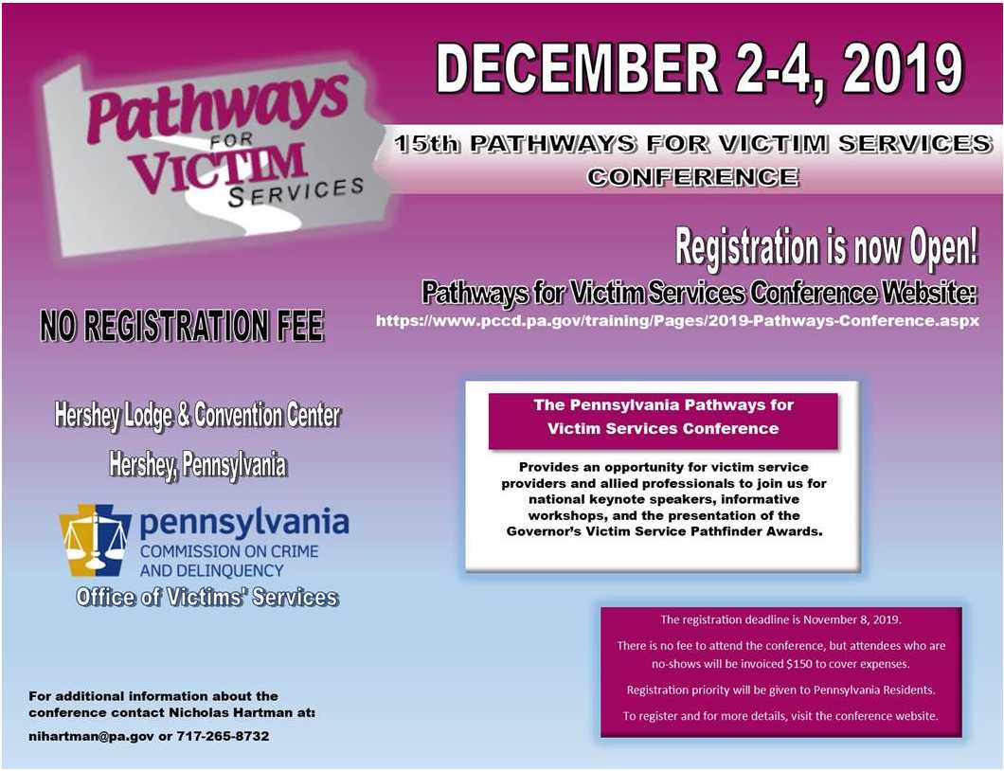
Return to top

If your program is offering new or extended services, or implementing new initiatives that you would like to highlight, please submit your news article to Stacie Brendlinger at sbrendling@pa.gov.
The next OVS Newsletter will be published on Wednesday, November 20, 2019. If you would like any training events, fundraisers, or notable news published in this newsletter, please submit them to Stacie Brendlinger at sbrendling@pa.gov by Wednesday, November 13, 2019.
You have signed up to receive the OVS Newsletter from the Office of Victims' Services. This newsletter will be sent to you on a biweekly basis via email. If your email address changes or you would like to be removed from the OVS Newsletter distribution list, please contact Stacie Brendlinger at (717) 265-8722 or via email at sbrendling@pa.gov.
Return to top
Pennsylvania’s Office of Victims’ Services | 3101 North Front Street | Harrisburg, PA 17110 | (717) 783-0551
www.pccd.pa.gov
PA Crime Victims Website
www.pcv.pccd.pa.gov
Twitter: @PaCrimeComm.

