Accessing No-Cost Naloxone in Pennsylvania

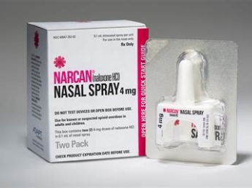
What’s Naloxone?
Naloxone is a life-saving medication used in the event of a suspected opioid overdose.

How Can Individuals & Organizations Get Naloxone in PA?
Individuals: In addition to accessing naloxone at their local pharmacy through the PA Department of Health’s standing order, community members can request the medication at no cost through PA’s statewide mail-to-home naloxone program.

Organizations & Agencies: Launched in 2017, PCCD’s Naloxone for First Responders Program (NFRP) provides and distributes free kits containing two 4mg intranasal doses to organizations and individuals who may encounter someone experiencing an overdose (“first responders”). A wide range of community-based organizations, agencies, and other entities are eligible to receive a supply of naloxone at no cost through Centralized Coordinating Entities (CCEs) across the state, or through PCCD’s NFRP request form. Some examples of just a few of the kinds of eligible first responders who can receive kits through the NFRP are below:

Community-Based Organizations | Healthcare | Criminal Justice & Reentry | Human Services | Education | Other Groups
- Harm Reduction  - SSPs  - Recovery Orgs | - Emergency Dept.  - EMS/EMT  - Primary Care Settings  - Clinics | - Prisons/Jails  - Law Enforcement  - Reentry Coalitions  - Probation/Parole | - Behavioral Health Providers  - Shelters (e.g., homeless, DV, etc.)  - Treatment Providers | - K-12 schools  - College + university campuses | - Parks + recreation  - Restaurants  - Hospitality  - Small business  - Transportation

Additional Training, Technical Assistance, and Resources
- PCCD’s Naloxone for First Responders Program:
Naloxone for First Responders (pa.gov)
- PCCD’s guidance for those receiving PCCD-purchased naloxone:
FY 2020-22 NFRP Guidelines for CCEs and Other Groups Receiving Naloxone.pdf (pa.gov)
- PA Department of Drug & Alcohol Programs
Naloxone
- Naloxone Trainings:
https://www.train.org/pa/admin/course/1085469/
Naloxone Nasal Spray Demonstration - YouTube
- Naloxone FAQs
NFRP General Public and First Responder FAQs.pdf (pa.gov)
- Technical Assistance for Grassroots/Community-based Organizations:
Prevention Point Pittsburgh (pppgh.org)

For additional questions about PCCD’s NFRP, please contact Sam Koch at sakoch@pa.gov or Alyssa Subsinsky at asubsinsky@pa.gov.

